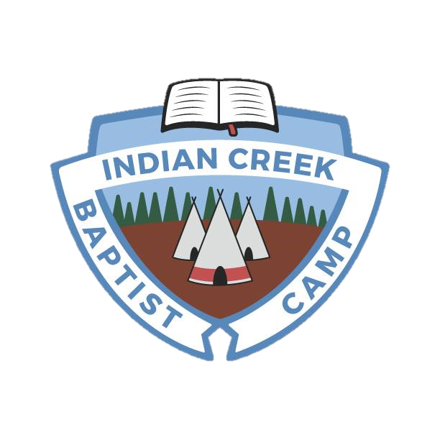
Camp Staff Application
Indian Creek 2018
Baptist Camp
Must be returned completed by March 1st, 2018

(Please type or print entire form)
Name____________________________________ Date of Application__________
Permanent Address__________________________________________________________
Street & Number City State zip

Birth-date______________________
How can we best get in touch with you to set up an interview when needed?
Phone____________________ Email______________________________

Dates available for summer _______________ to _______________
Known dates you might need off through the summer (please list reason also)

Past work history: Provide a full record of all employment – paid and volunteer – and explain any gaps in employment. Use a separate sheet if necessary.
Dates | Employer/Supervisor | Address & Phone | Job/Task | Reason for Leaving
Indicate any employer you’d like us not to contact, and the reason

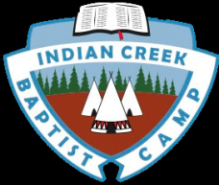
References: Please provide names and contact information (non-relatives) who
Have knowledge of your character, experience, work habits, and ability.
Name | Email or address | Phone

Education Experience
Years | School | Major areas of study | Degree Granted

Camp Experience
Dates | Camp & Director | Location | position

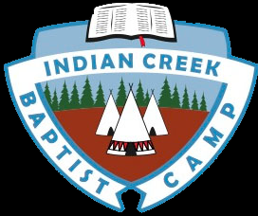
Please answer the questions below in a detailed fashion, if you need to, use a separate sheet of paper.
Why is camp important to you?
__________________________________________________________________________________________________________________________________________________________________________________________________________________________________________________________________________________________________________________________________________________________________________________________________________________________________________________________________________________________________________________________________________________________________
Describe the skills or passions you have that might be useful to a position on camp staff. ________________________________________________________________________________________________________________________________________________________________________________________________________________________________________________________________________________________________________________________________________________________________________________________________________________________________________________________________________________________________________________________________________________________________________________________________________________________________________________
What is a something you’ve noticed (either a person or situation) about camp staff in the past few years that you’ve admired, enjoyed, or wanted to be a part of? _____________________________________________________________________________________________________________________________________________________________________________________________________________________________________________________________________________________________________________________________________________________________________________________________________________________________________________________________________________

Describe a time when you were part of a team (or group), and talk about what helped that team work together to achieve goals (even if you did not have success in achieving those goals) ___________________________________________________________________________________________________________________________________________________________________________________________________________________________________________________________________________________________________________________________________________________________________________________________________________________________________________________________________________________________________________________________________________________________________________________________________________________________________________________________________________________________________________________________________________________________________________________________________________
Harassment: The camp’s policy is to prohibit all forms of harassment by our employees. This includes sexual, racial, religious, and other forms of harassment. Have you ever been accused of harassment of any person including, but not limited to workplace harassment? (Note: prior accusations are not an automatic disqualification from employment.) If yes explain;
__________________________________________________________________________________________________________________________________________________________________________________________________________________________________________
Criminal Record: Have you ever been convicted of a crime, (other than a minor traffic violation)? If yes please describe. __________________________________________________________________________________________________________________________________________________________________________________________________________________________________________
I authorize investigation of all statements herein, including any check of criminal records, and release the camp and all other from liability in connection with same. I understand that, if employed, I will be an at-will employee unless there is agreement or law which alters that status. Furthermore, I understand that any agreement must be in writing and signed by the designated camp official. I also understand that misrepresentations or falsifications herein or in other documents completed or submitted by the applicant will result in dismissal regardless of date of discovery by the camp.
Signature_____________________________________________________ Date_________________

