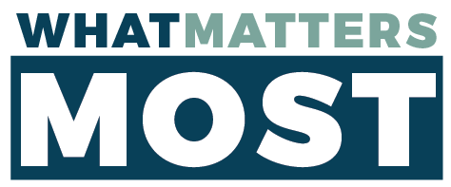
Please return this form
to the Conference Office by Nov 1.
Return to: 11501 SE Sunnyside Rd, Suite 200, Clackamas OR 97015 (or) nancy@pacificecna.org

Minister’s Name: __________________________________________________________

- In what local church do you have membership?

- In what church are you presently serving as a commissioned minister?

- What is your current role as a commissioned minister?

- Is your commissioning certificate valid/up-to-date?

