SEPTEMBER/OCTOBER 2016 NEWSLETTER
Sherrill’s Ford Presbyterian Mission Statement
We, the members of Sherrill’s Ford Presbyterian Church, are called by God
- To share the Gospel and bring others to Christ,
- To grow spiritually,
- To be a loving and supportive family in Christ,
- To work to make the world a better place in which to live.

Pastor’s Pulpit
May the Peace of Jesus be with all of you!
Marcia and I are so excited that our Lord continued to talk to us about where He wanted us even after we had shared with our Session last year that we thought 2016 was supposed to be our last year of ministry. What’s that old saying, “If you want to make God laugh, tell Him your plans.” Well, we obviously made Him laugh.
Our church is exciting! There is strong life running through our church - from Bitsy and the youth to Jackie and Dawn with the Crafting Ladies and many “stops” in between. We have our choir, Catawba Elementary Clothing Closet, Presbyterian Women, Presbyterian Men, evening Bible Study, Saturday Craft Day, Abernathy Laurels, plus our regular Sunday worship - with at least eight additional special services each year. On top of all that, there will always be something “special” around the corner - cantatas, Healing & Wholeness Service, Festival of Tables. These are just a few of the special services and activities coming this fall. Please participate wherever our Lord leads you. You are the church! Our Lord has said directly that we are to be His hands and feet here on earth.
Our church, which is you, also needs your support: Time, Talents, and Financial. We are blessed to have an extremely generous church family. We have a fantastic facility. Very few churches our size have buildings with the flexibility of ours. God wanted us to have that flexibility. Not counting our worship services, choir, youth, AA, Bible Study, family reunions, crafters, Home School, and other groups, our building is in use 280 days per year! Very few churches our size use their facilities as much as we do. Our Lord loves that! But, with all of that, our church needs your continued financial support. This year alone, we have had to replace the roof, had electrical issues, one of our A/C units stopped working, and we now have a safety issue with the outside hand rails and are receiving estimates to replace them. In order to make your giving more convenient, you may contribute financially online by just going to our website. Please give where and how our Lord leads you.
God wants you to be part of His church. He desires a deep and personal relationship with each of us.
Marcia and I are richly blessed to be here, walking His path, with each of you.
Peace to All
SHERRILL’S FORD PRESBYTERIAN CHURCH
P. O. Box 246, Sherrill’s Ford, NC 28673
Phone: 828-478-2223
Church Website: www.sfpchurch.org
Russ and Marcia Reighley, Pastors Elizabeth Brownell, Music Director
Carol Sticco, Clerk of Session, Administrator Jane Shoemaker, Congregational Care
Wendy Bandel, Mission David Miller, Building & Grounds
Lisa Hicks, Worship Bobbie Williams, Fellowship

Elder Spotlight of the Month –
David Miller

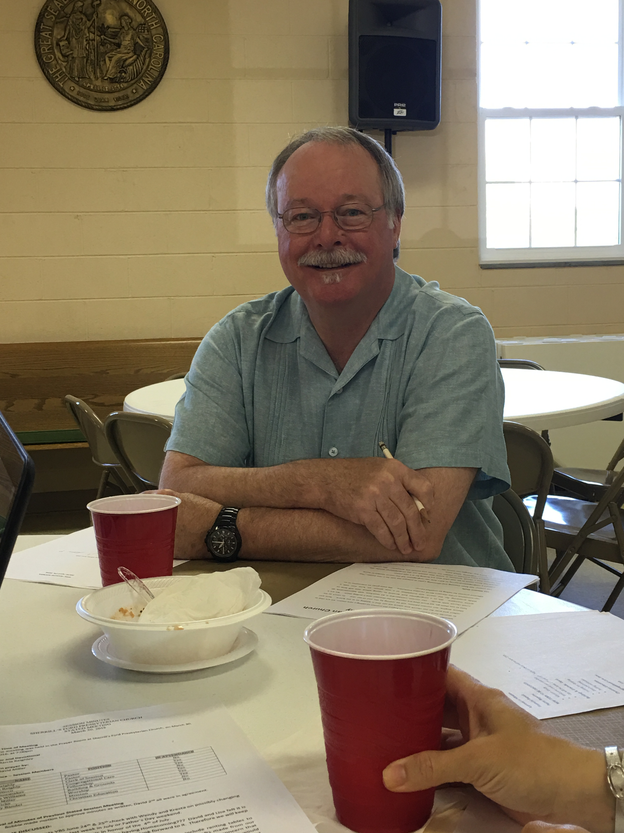

Dear Friends in Christ,
As the time for seasonal changes come our way, I cannot help but reflect upon the changes that have taken place in our church in the last year. The births, deaths, marriages, new members, baptisms, changes in jobs, retirements and many more.

Many people have been very busy making changes in our church through one or more of the committees we have. I would like to ask those of you who are not on one of the committees to consider joining one. Your thoughts and energy are more than welcome and will be put to good use.

I am very proud to be on the Session for SFPC. We have a strong and dedicated collection of caring people. If you have ideas to improve our church, please contact any one of the Session members and give us your input.
Thank you.
I wish you peace and God's love,
David Miller

Music Notes:

The choir shared special music at Abernethy Laurels in Newton presenting “Celebrate America” for the residents at their Vesper Service the end of July. It is always a special time worshipping with the residents there.

Now that the summer season is coming to a close, we are starting to prepare for the upcoming Advent season. Our cantata, One Small Child, will be presented on December 18th and again in January at Abernethy Laurels. Rehearsal time begins at 7:30 on Monday evenings after we prepare for Sunday services. We would love to have you join us – and sing on Sundays too!

“Yet a time is coming and has now come when the true worshipers will worship the Father in the Spirit and in truth, for they are the kind of worshipers the Father seeks.” John 4:23

Weekly Events
Monday 9:30am Crafts
7:00pm Choir Rehearsal
Wednesday 7:00pm AA Meeting
Thursday 7:00pm Bible Study

Calendar of Events
- Sunday, September 4th 8:00am
Men’s Breakfast
- Sunday, September 11th 6:00pm
Healing & Wholeness Service
- Sunday, September 25th 11:00am Homecoming with Covered Dish Luncheon
- Sunday, October 2nd 8:00am
Men’s Breakfast
- Sunday, November 6th 8:00am
Men’s Breakfast
- Sunday, November 13th
Veteran’s Day Service
- Wednesday, November 23rd 7:00pm
Thanksgiving Eve Worship Service
- Saturday, November 26th 9:00am Decorate for Hanging of Greens
- Saturday, November 26th 6:00pm
Hanging of the Greens Service
(Heavy hors d’oeuvres and desserts)
- Sunday, December 4th 8:00am
Men’s Breakfast
- Saturday, December 10th 11:30am
Festival of Tables Fundraiser
- Thursday, December 15th 7:00pm
Longest Night Service
- Sunday, December 18th 11:00am
One Small Child
- Saturday, December 24th 7:00pm
Christmas Eve Service
- Saturday, December 24th 11:00pm Christmas Eve Communion Service
- Sunday, December 25th 11:00am
Christmas Day Communion Service

Presbyterian Women Upcoming Events
- September 6th 10:00am
Monthly Meeting
- September 24th – Fall Gathering
First Presbyterian Church, Gastonia Registration deadline is September 20th. Contact Doris Brown for forms or if you have any questions.
- October 2nd and 9th – Blanket Sunday
- October 4th 10:00am
Monthly Meeting
- October 22nd – 2pm-4pm
Baby Shower for Jenaleigh Beatty Ohlin
- November 8th 10:00am
Monthly Meeting
- December 5th – PW Christmas Party at Lineberger’s

American Red Cross – Blood Drive
Monday, September 12th
3:00 - 7:30pm
Volunteers: Greeter, Sponsor, Canteen, helping to unload truck at 2:00pm and loading truck after drive.

Donate blood, and bring a friend to donate with you.
There is a need for sandwiches, drinks and baked goods. If you are interested in volunteering the day of the drive or in donating any refreshments, please contact Jane Shoemaker at 828-404-6774.

Youth Group
We welcome all middle and high school students (and their friends). Our goal is to offer a time for fellowship for the youth as well as provide service opportunities so they may give back to our community. We will be meeting twice a month in the Fellowship Hall on Sundays at 6pm – see schedule below. There is no fee for the activities at the church. On occasion, the youth may need money for a burger or pizza.

Encourage your children, grandchildren, neighbors and others you may meet to come so they may enjoy the warmth of our church and receive the pleasure of serving the community through God.

Recent Youth Group Activities
A big thank you goes out to Bitsy Gregory for keeping our youth so active. Here are a few of our past events:

Sky High, Charlotte, NC
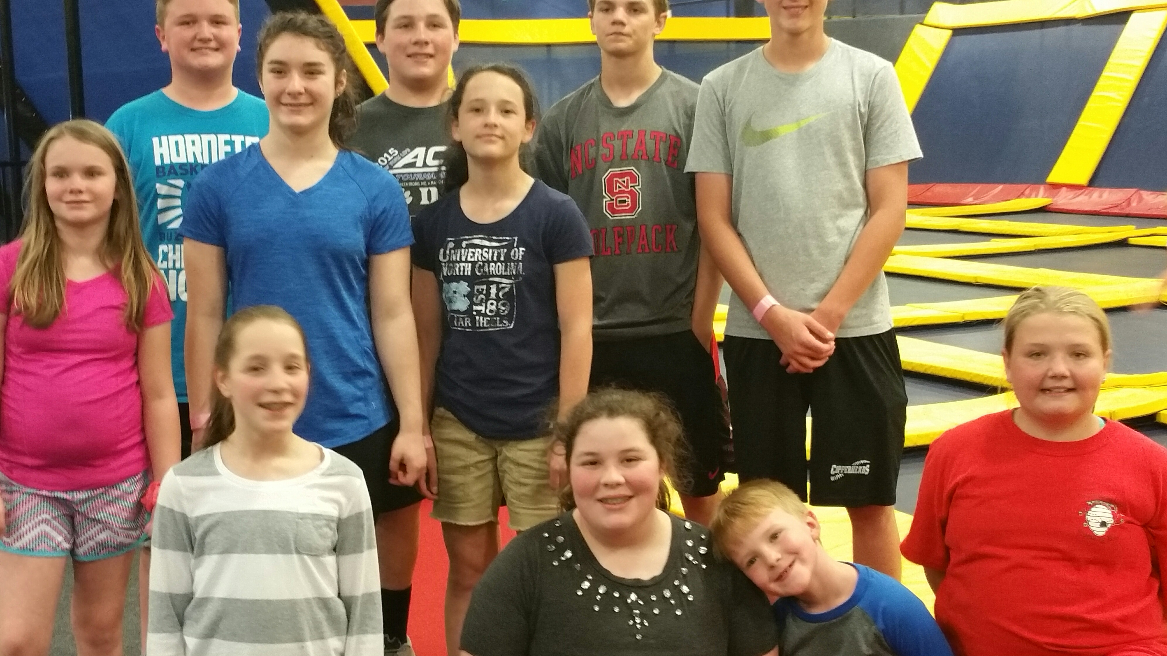

Crawdads Game
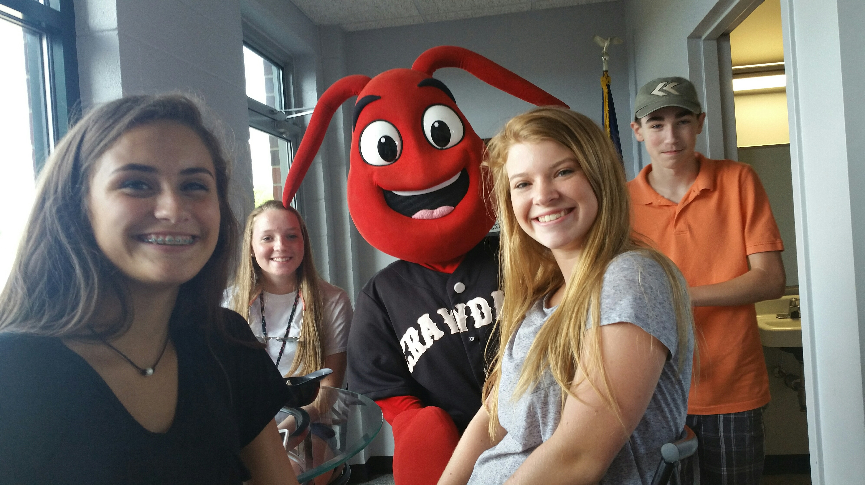

Making Care Bags for the Homeless
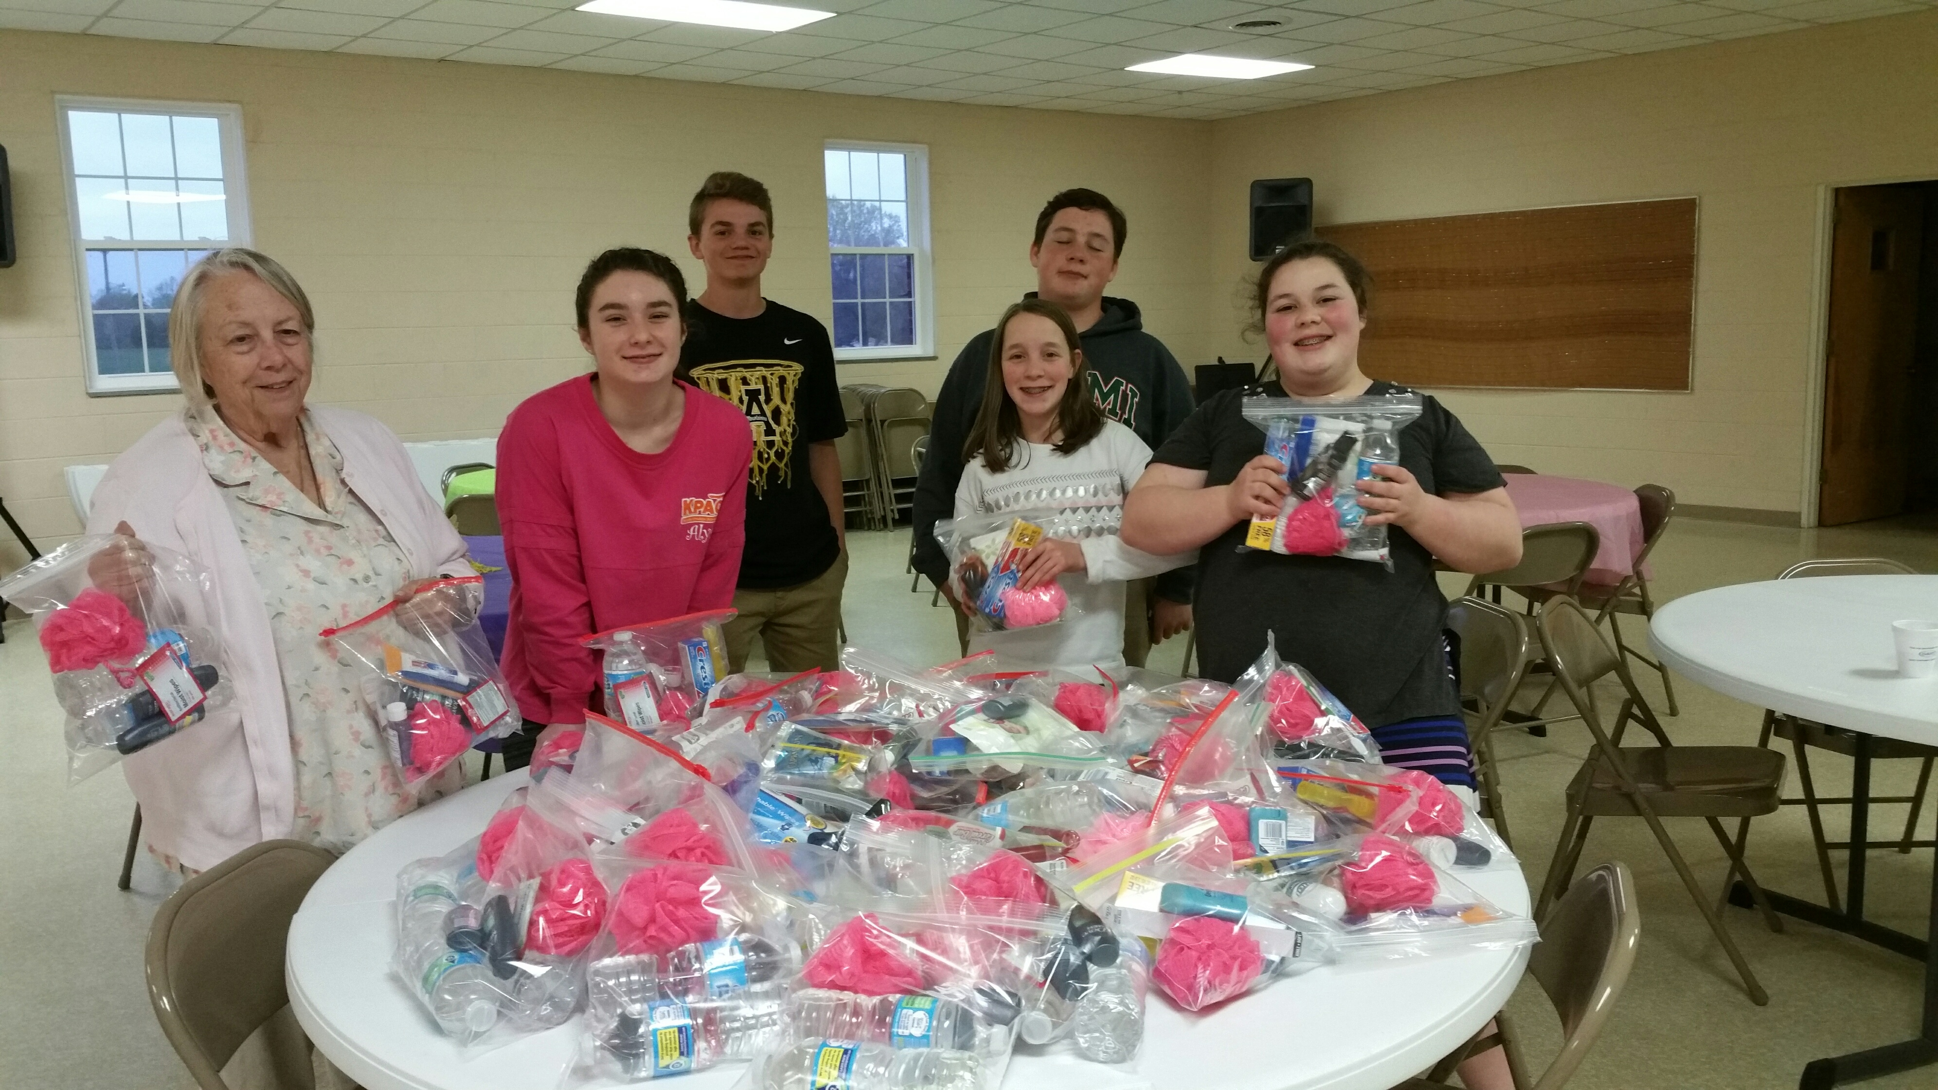
Youth Group Upcoming Events
- Sunday, September 25th - Bowling
- Saturday, October 15th - Provide Services for Members
- Sunday, November 13th - Sky High or Ice Skating
- Sunday, December 4th - Cookie Swap & Delivery

Scriptures for September & October
September

4 Psalm 139 & Luke 14:25-33

11 Psalm 14 & Luke 15:1-10

18 Psalm 79:1-9 & Luke 16:1-13

25 Psalm 91:1-6 & Luke 16:19-31

October
2 Psalm 137 & Luke 17: 5-10

9 Psalm 66:1-12 & Luke 17:11-19

16 Psalm 119:97-104 & Luke 18:1-8

23 I Timothy 4:6-8 & Luke 18:9-14

30 2 Thessalonians 1:1-4 & Luke 19:1-10

Ushers for the Month of September
Jim Edwards Jerry Beatty
Dan Yonkin JW Brotherton

Ushers for the Month of October
Jane Shoemaker Bob Chambers
Dane Beatty Jenny Johnson

Acolytes
Alyssa Bandel
Mackenzie Pedicino

Crafty Saturdays
Join us and get motivated to get those unfinished projects completed or just come to enjoy the fellowship. Our first work day, we got a little work done and had a lot of laughs.

Bring your projects to work on and a snack to share. Invite your friends too!

We are hoping to schedule some special classes. More information will be provided once those are determined.

We will be meeting 9am to 12pm the third Saturday of each month through November: September 17th, October 15th and November 19th.

Contact Joy Beatty (828-478-2768) or Elizabeth Brownell (704-682-2410) if you have any questions.
You Are Invited
The family of Willie Beatty invite you to share in celebrating her 90th birthday on Sunday, October 9th. The celebration will in the Fellowship Hall from 3pm-5pm. Your presence will be her gift!

Happy Birthday
Birthdays are important because they indicate a special moment when God selected us to live in time. We are very special to have been chosen by Him to serve in His Kingdom in this generation. Please inform Carol Sticco if there are any additions or corrections needed.

September 2 Jacob Bandel
September 13 David Miller
September 17 Ricky Beatty
Mary Kennedy
September 18 Sammy White
September 24 Maddie Mirman
Caroline Mirman
Nate Mirman
September 25 Joy Lynn Beatty
September 27 Willie Beatty

October 8 Von Beatty
October 9 Alex White
October 17 Jennifer Humphreys
October 19 Ida Edwards
October 20 Aaron Brownell
October 21 Doug Shoemaker
October 22 Kris Mirman
October 27 Dorothy Clifford
Joyce Beatty

Happy Anniversary
September 7 Bob & Mary Kennedy
September 27 Michael & Ashley Sticco
September 30 David & Cindy Miller

October 6 Steve & Beth Caldwell
October 10 Dennis & Fran Rumpf
October 29 Carl & Lisa Hicks

Fellowship Hall
If you are interested in reserving the Fellowship Hall for your next special event, please visit the calendar on our website sfpchurch.org to check availability. You can also contact Carol Sticco at 828-217-5616.
The following dates are reserved:
- September 11 – White Family Reunion
- September 13 – 5pm Home School
Baking Contest
- September 17 – 9am Crafting Day
- September 17 – 1pm Lisa Peltack
- September 18 – Beatty Family Reunion
- September 25 – Homecoming
- October 8th & 9th – Willie Beatty’s Birthday Celebration
- October 15 - 9am Crafting Day
- October 22 – Jenaleigh Ohlin Baby Shower
- November 19 – 9am Crafting Day
- November 24 – Joan Washam Family
- November 26 – Hanging of the Greens
- December 10 – Festival of Tables

Recipe of the Month:
Chicken Enchilada’s

Ingredients
1 small red onion, halved
1 1/2 pounds tomatillos, husked and rinsed
1 to 2 serrano chile peppers, stemmed and seeded
1/2 cup low-sodium chicken broth
Kosher salt
Pinch of sugar
8 corn tortillas
3 cups shredded rotisserie chicken
2 1/2 cups shredded mozzarella and/or Monterey Jack cheese
1/3 cup fresh cilantro
2 tablespoons extra-virgin olive oil, plus more for greasing
3/4 cup crumbled queso fresco or feta cheese
Directions:
Preheat the broiler. Slice half of the onion into thin rings and set aside. Place the other onion half, tomatillos and serranos on a foil-lined baking sheet and broil until the vegetables are soft and slightly brown, 7 to 10 minutes, turning as needed. Transfer the vegetables and any liquid to a blender, add the broth and puree. Season with 1/2 teaspoon salt and the sugar.
Meanwhile, stack the tortillas, wrap in a damp paper towel and microwave just until warm and soft, 1 minute; keep covered. Toss the chicken with 2 cups shredded cheese in a bowl. Spoon a portion of the chicken mixture down the middle of each tortilla. Add a few cilantro leaves and roll up. Place the enchiladas side by side in a lightly oiled 9-by-13-inch baking dish and brush with the 2 tablespoons olive oil. Broil until crisp and golden, 3 minutes.
Pour the tomatillo sauce over the enchiladas and top with the remaining 1/2 cup shredded cheese. Return to the oven and broil until the cheese is bubbly and golden brown, 3 to 5 minutes. Garnish with the onion rings, queso fresco and any remaining cilantro.

