MAY/JUNE 2016 NEWSLETTER
Sherrill’s Ford Presbyterian Mission Statement
We, the members of Sherrill’s Ford Presbyterian Church, are called by God

- To share the Gospel and bring others to Christ,
- To grow spiritually,
- To be a loving and supportive family in Christ,
- To work to make the world a better place in which to live.

Pastor’s Pulpit

During these past 6 weeks of spring, I have noticed many fresh varieties of fruit filling the grocery store shelves. The soil and trees which had appeared dormant during the long months of winter began the transformation process from one season into another producing delicious fruit. We are not so different from fruit plants and trees in that we can appear to be dormant on the outside while all along the fruits of our spirits are growing and maturing during the winter days of our souls. For Christians who desire to produce a spring harvest of spiritual fruit, we will have been experiencing spiritual growth that occurs deep within us as we have engaged in Bible reading and study. This intentional growth causes a transformative process to take place deep within our souls much like the hidden process which occurs underground in the roots or deep inside the plant's stems, leaves and/or trunks. When adequate maturity has occurred, we like the fruit trees will produce ripe delicious fruits of the spirit - love, joy, peace, kindness, goodness, faithfulness, perseverance, patience and self-control. I really enjoy eating fresh seasonal fruit, and I am certain my family and friends appreciate my company much more when I can share mature spiritual fruits. May each of us take an inventory of this season’s fruit production and strive to produce even more spiritual fruit next spring.
Radiant peace,
Pastor Marcia

SHERRILL’S FORD PRESBYTERIAN CHURCH
P. O. Box 246, Sherrill’s Ford, NC 28673
Phone: 828-478-2223
Church Website: www.sfpchurch.org
Russ and Marcia Reighley, Pastors Elizabeth Brownell, Music Director
Carol Sticco, Clerk of Session, Administrator Jane Shoemaker, Congregational Care
Wendy Bandel, Mission David Miller, Building & Grounds
Lisa Hicks, Worship Bobbie Williams, Fellowship

Elder Spotlight of the Month –
Bobbie Williams

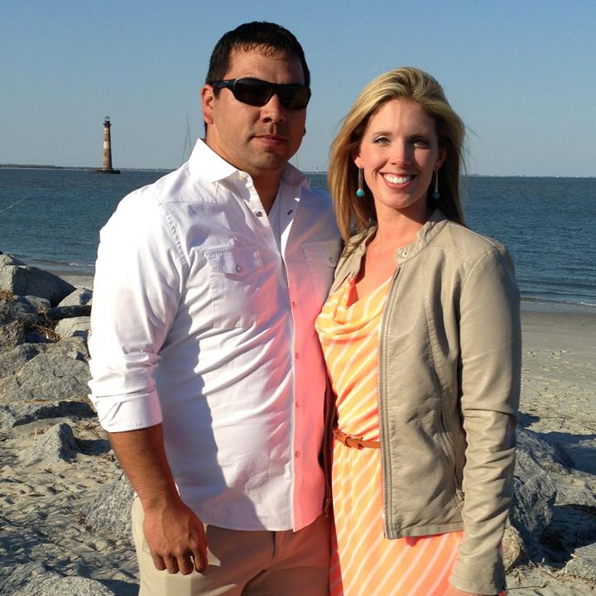

My name is Barbara “Bobbie” Williams. My family, the Whites, were one of the founding families of Sherrill’s Ford Presbyterian Church. I am married to my high school sweetheart. We have been married for almost 12 years. We have a wild and crazy 2 year old, and we are expecting our second son in September. I am a Nurse Anesthetist and currently work at Presbyterian Medical Center in Charlotte. I love my career and truly enjoy taking care of each and every patient. Needless to say, life is always a little crazy, but I love it and wouldn’t have it any other way.

A Tribute to Mothers
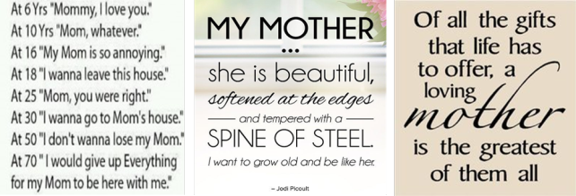
It’s sleepless nights, it’s nursing scratches and scrapes, it’s being stern and protective. It’s building their self-esteem, supporting their dreams and loving them unconditionally. It’s a connection that is unmatched a love that grows continually, a love that always wants more and better. It’s being terrified that you can’t prevent pain, injustice, heartbreak and at times even death. It’s always being available for the “Mommy watch me!” yells and “Mommy, I need you please”. It’s a blessing, a gift, a relationship that never ends and a love that never dies.

A Tribute to Fathers
Past Events – Easter Egg Hunt

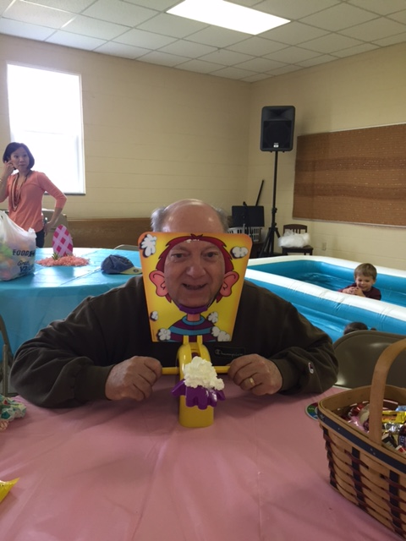
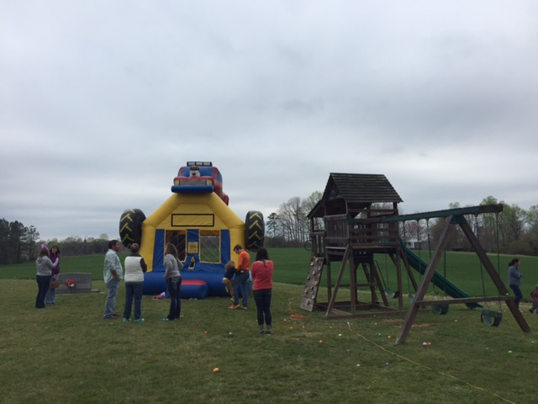
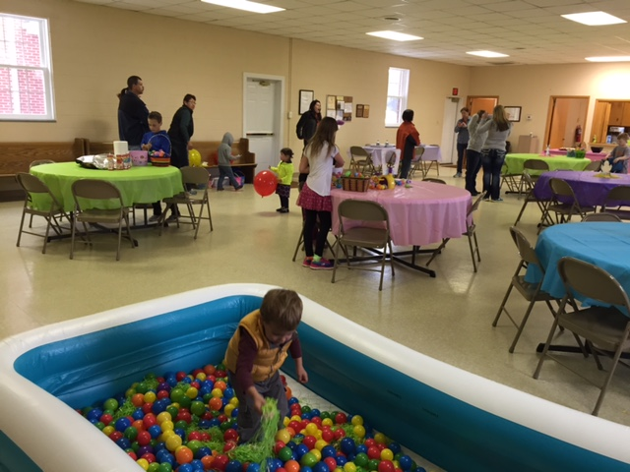

Maundy Thursday Service –

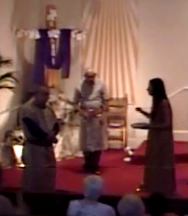

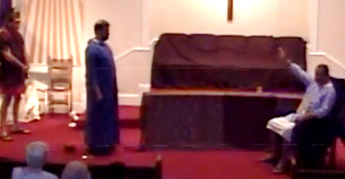

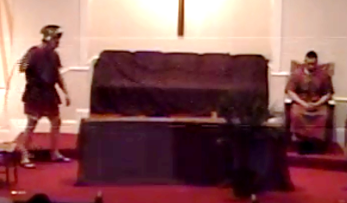
Weekly Events
Monday 9:30am Crafts
7:00pm Choir Rehearsal
Wednesday 7:00pm AA Meeting
Thursday 7:00pm Bible Study

Calendar of Events
May 1st Communion Sunday
May 8th Mother’s Day
May 15th Pentecost Sunday
May 20th Israel Night with dinner at 6:15
(Russ’s recent trip)
May 30th Memorial Day

June 17th-18th Vacation Bible School
June 19th Father’s Day
June 25th Celebrate America!
Presented by the choir at 6:00p

July 15th–17th Synod of the Mid-Atlantic Presbyterian Men’s Conference

Presbyterian Women Upcoming Events
Sunday May 1st – PW Birthday Objective Program

The program will be held in the Fellowship Hall after the worship service. You are invited to join us for a short program. Lunch will be provided.

Youth Group

We welcome all middle and high school students (and their friends). Our goal is to offer a time for fellowship for the youth as well as provide service opportunities so they may give back to our community. We will be meeting twice a month in the Fellowship Hall on Sundays at 6pm – see schedule below. There is no fee for the activities at the church. On occasion, the youth may need money for a burger or pizza.

Encourage your children, grandchildren, neighbors and others you may meet to come so they may enjoy the warmth of our church and receive the pleasure of serving the community through God.

Youth Group Upcoming Events
Sunday May 1st
6pm “Care Packages” for the Rescue Mission
Friday May 13th
4:45pm The Speed Park at Concord Mills
We will need a head count by Monday, May 9th. Please contact Carol Sticco at
828-217-5616.
Sunday May 15th
6pm Deliver “Care Packages” for the Rescue Mission
Friday June 3rd
6pm Relay for Life (overnight event)
Sunday June 12th
3pm Swim Party with picnic dinner
Saturday July 30th
6pm Hickory Crawdads Game
(Christian concert following game)
Western North Carolina Presbytery Meditation:

Love is the Spirit
A Meditation for Pentecost Season
Where does the Holy Spirit fit in the life and faith of the believer? In the confessional theology of most Christians, the Holy Spirit is one person of the Trinity. You know, “God in three persons, blessed Trinity.” Stated as doctrine, the person and work of the Holy Spirit is the assurance that God is present in our lives, not only as our Creator and Redeemer, but as our Counselor and Comforter.
But let’s get beyond theology where we think everything must fit together in a kind of logical, orderly way. There we discover that the Holy Spirit is in fact a free agent, moving where she will. Yes, she! Because the ancient (Hebrew) word for “spirit” is a feminine word, it is fair to use this pronoun and to attribute feminine traits to the Holy Spirit.
Nowhere is the character of the Holy Spirit clearer than when we say, “God is love” and “Love is of God.” The promised Holy Spirit comes as the wind and fire, enlivening disciples today as on the day of Pentecost long ago. We are possessed by the Spirit of the risen Christ. We are sent out into the world to witness to the grace of God at work in the world and to show the limitless love which has claimed us.
I believe the Holy Spirit is Christ’s living presence, found in each word and action of selfless love. That’s the Spirit!
Community News
Message from the Catawba Council for Seniors Hello Friends,
What beautiful weather we’re having! Makes us want to get out of the house and enjoy it, right? Come over to the Senior Center and spend time with friends!
We are celebrating Older Americans Month in May with our friend David Harvell. He’ll bring to us those old familiar gospel songs that will have you tapping your toes and remembering good times.
Like tacos? Join us for this tasty treat and play a couple of games of Bingo with us!
You might think it’s too early to think about Christmas, but our friend Peggy Darnell will show you how to make those beautiful quilted ornaments to give you a head start on making these for your friends and relatives this year. They make nice gifts that folks can cherish for a long time to come!
On a more serious note…Attorney Susannah Brown will present a program about probate and estate planning. It’s good to know these things!
New to Medicare? We have lots of good information to share with you about your insurance options.
The Veterans Benefits and Medicare Program will help clarify these benefits and how they coordinate.
We thank our friends at Hospice for providing a lunch-n-learn opportunity to help you prepare your advance directives and health care wishes.
Our friendly computer tutor will be back to help you learn more about your tablets and I-Pads.
We’re here to help!
Give us a call or come see us sometime.
Rosemarie Hefner
Administrative Assistant
Catawba County Council on Aging

Results from our Pastoral Survey:
Session would like to thank everyone for taking the time to fill out the Pastoral Survey. Listed below you will find the results from the majority of those returned:
- Change to the Mission Statement? The words “in which” were added to the Mission Statement.
- What is the desired age of our future pastor? No Preference.
- What is the minimal acceptable education level you expect? Certified Licensed Pastor (Lay Minister)
- What experience in ministry do you want the perspective pastor to have? Equal response of 1-5 years experienced pastor, and 6-10 years prior church ministry.
- Would you like the future pastor to be full time or part time? Full time.
- Which of the following do you consider the most important strengths needed in an incoming pastor? Strengths needed were preaching, leadership, and administration.
- The following are activities to which a pastor may allocate time each week. Prayer, sermon preparation and counseling were the top three responses.
- Compared to our current worship service, would you want the prospective pastor to lead in making any of the following changes? Use the same as today but include more contemporary music.
- Which of the following elements of preaching style most effectively communicate God’s Word to you? Personal, textual and narrative were the top three responses.

Teaching Scriptures for May & June
May 1st John 5: 1-9 & 14: 23-29
“If You Love Me, You will Obey”
May 8th John 17: 20-26
“Jesus Prays for Future Believers”
May 15th Pentecost; Acts 2: 1-21 & John 14: 20-26
May 22nd John 16: 12-15
“The Spirit will Guide Us to the Truth”
May 29th Luke 7: 1-10
“The Centurion Shows Faith”

June 5th Galatians 1: 11-24
“Paul’s Personal Story”
June 12th Galatians 2: 15-21
“How We Can Work Together”

June 19th Galatians 3: 23-23
“Before Faith, we were Prisoners”
June 26th Galatians 5: 1, 13-25
“Fruits of the Spirit”

Ushers for the Month of May

Ricky Beatty Bitsy Gregory
Richard Harwell Jenny Johnson

Ushers for the Month of June

Jim Edwards Jerry Beatty
Dan Yonkin JW Brotherton

Acolytes
Alyssa Bandel
Mackenzie Pedicino

Happy Birthday
Birthdays are important because they indicate a special moment when God selected us to live in time. We are very special to have been chosen by Him to serve in His Kingdom in this generation. Please inform Carol Sticco if there are any additions or corrections needed.

May 1 Norman Dillingham
May 1 Emmalee Cross
May 3 Marcia Reighley
May 5 Nicole Morford
May 13 Jacob Bach
May 18 Rylan Fisher
May 25 Whitney Miller
May 27 Jimmy Shoemaker

June 8 Russ Reighley
June 9 Nell Sherrill
June 14 Bill Greenwood
June 15 Karen Phillips
June 19 Jackie Hefner
June 19 Dan Yonkin
June 20 Michael Sticco
June 26 Eugene Mason
June 27 Yvonne Edwards
June 28 Pat Brotherton

Happy Anniversary

May 3 Norman & Linda Dillingham
May 7 Doug & Jane Shoemaker
May 11 Richard & Geneva Harwell
May 15 Chad & Bobbie Williams
May 17 Andy & Wendy Bandel
May 21 Ed & Jenny Fisher
May 25 Charles & Vivian White

June 10 Von & Joyce Beatty
June 20 JW & Pat Brotherton
June 27 Mike & Carol Sticco

Fellowship Hall

If you are interested in reserving the Fellowship Hall for your next special event, please visit the calendar on our website sfpchurch.org to check availability. You can also contact Carol Sticco at 828-217-5616.
The following dates are reserved:
- May 1 – PW Birthday Objective Program and Lunch
- May 13 – Awards Ceremony Set Up
(Home School)
- May 14 – Awards Ceremony and Talent Show (Home School)
- June 12 – Isaac Humphrey’s Baptism
- June 17 – 18 – Vacation Bible School
- June 25 – Celebrate America! Patriotic Cantata
- June 26 – Gilleland Family Reunion
- July 17 – Cornelius Family Reunion
- August 27 – Gabriel Family Reunion
- September 11 – White Family Reunion
- September 18 – Beatty Family Reunion
- September 25 - Homecoming
- October 1st and 2nd – Willie Beatty’s Birthday Celebration
- October 8 – Community Day
- November 24 – Joan Washam Family

