JULY/AUGUST 2016 NEWSLETTER
Sherrill’s Ford Presbyterian Mission Statement
We, the members of Sherrill’s Ford Presbyterian Church, are called by God

- To share the Gospel and bring others to Christ,
- To grow spiritually,
- To be a loving and supportive family in Christ,
- To work to make the world a better place in which to live.

Pastor’s Pulpit

The Glory of the New Covenant in Our Land
2 Corinthians 3:17
Now the Lord is the Spirit, and where the Spirit of the Lord is, there is freedom. NIV
Early in our nation’s history we were held captive under British law. Our Land was under the British government and obligated to pay, what our early ancestors felt to be unfair taxes, similarly, the Israelites were held captives under the Law (all 613). These governments promised death, death of the New World and death of the Human Spirit
The new world revolted and was victorious in defeating England and declared their new Constitution on Independence Day July 4th 1776. The Declaration of Independence and the Gospel (new covenant) brought freedom to the captives. Our American ancestors no longer had to work under the authority of the British government and likewise our Spiritual ancestors no longer were obligated to obey the religious establishment, the only requirement was their personal belief that Jesus is the Son of God.
Freedom is costly, it cost the lives of many during the Revolutionary War and the glory of the New Covenant cost Jesus Chris his life. Our ancestors recognized that God is personally present, a living Spirit, that the old constricting legislation was obsolete. They were freed of it and so are we!
Amazed by Grace,
Pastor Marcia
SHERRILL’S FORD PRESBYTERIAN CHURCH
P. O. Box 246, Sherrill’s Ford, NC 28673
Phone: 828-478-2223
Church Website: www.sfpchurch.org
Russ and Marcia Reighley, Pastors Elizabeth Brownell, Music Director
Carol Sticco, Clerk of Session, Administrator Jane Shoemaker, Congregational Care
Wendy Bandel, Mission David Miller, Building & Grounds
Lisa Hicks, Worship Bobbie Williams, Fellowship

Elder Spotlight of the Month –
Lisa Hicks

I am blessed to be a member of Sherrill’s Ford Presbyterian Church. I was raised as a Baptist but joined in 1986. My mom, who was raised here encouraged me to visit after she started coming in the late 1980’s. Once I came, I realized that this was the church for me. I was married here in 1988 to my wonderful husband Carl. I have served as an Elder several times, taught Sunday School and VBS. My real passion is singing, at home, at work or in the car! I have been in the choir for a number of years and love the group we have. We always have a great time singing and worshiping God in song. I am a RN and work at the Iredell Surgical Center in Statesville. I will celebrate 25 years there this coming October. My husband has a motorcycle and we love to take rides when the weather cooperates. I love my church and church family and am so thankful for both.

Music Notes:
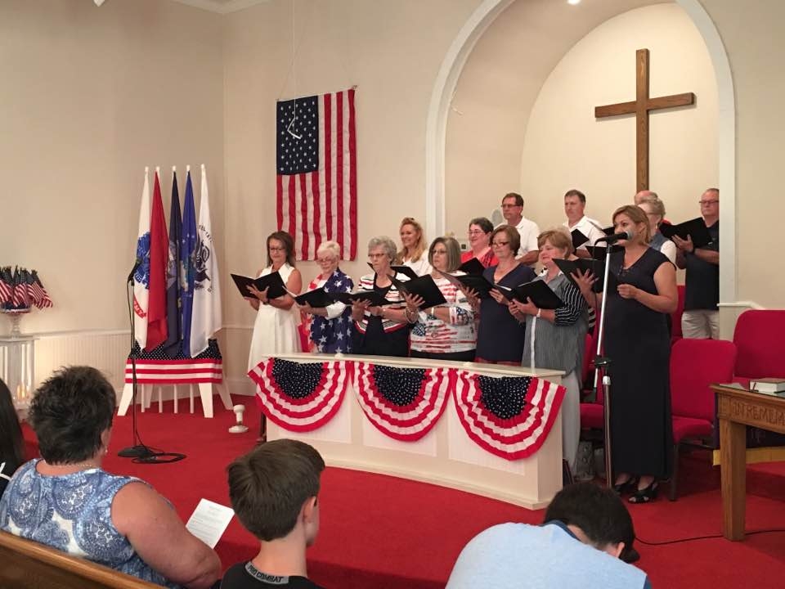
On Saturday, June 25th, the choir presented “Celebrate America”. The church was packed with over 100 in attendance – plus the choir. During the music presentation, Veterans and First Responders were recognized and given a small gift of appreciation for their service. Some of the many positive comments by church members as well as guests from the community:
“I have never felt more appreciated as a veteran.”
– Brian Sutton
“Wonderful and touching presentation.”
– Ramona Edwards
“This was a really special gift you provided to our community. Thank you so much.”
– Kate Frederici

“It has been a long time since I have felt pride for this country.”
– John Miller
“It is great to be thanked.”
– Bob Klatt
After the presentation, there was an “indoor picnic” with hotdogs, all the fixings, watermelon, desserts and homemade ice cream. It was exciting to have to get out MORE tables and chairs to accommodate everyone.

Thank you to everyone who helped put out signs, prepared food, set up / cleaned up Fellowship Hall, and decorated sanctuary. A special thank you to every choir member; Dennis Rumpf, narrator; Vivian White, canvas painting of cover art; and Aaron Brownell, sound. Without everyone giving of their time, the evening would not have been made possible.

If you were not able to attend, the choir will be presenting “Celebrate America” again on Sunday, July 31st at Abernethy Laurels in Newton. The service will be at 4:00.

“Blessed is the nation whose God is the Lord.” Psalm 33:12

Past Events – VBS – The Armor of God

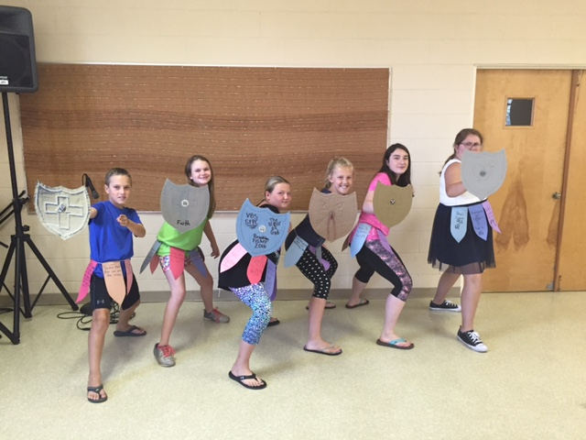
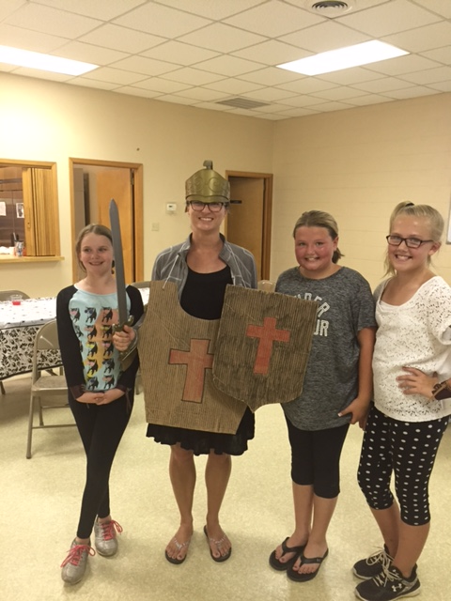
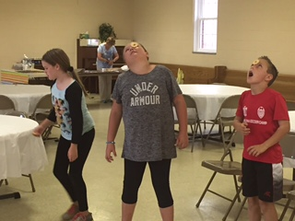
Weekly Events
Monday 9:30am Crafts
7:00pm Choir Rehearsal
Wednesday 7:00pm AA Meeting
Thursday 7:00pm Bible Study

Calendar of Events
July 15th PW Family Outing Sports Page
July 21st 9am Son Shiners Breakfast
July 23rd 9am Session Members meeting with
Barbara Ross

Presbyterian Women Upcoming Events
Friday July 15, 2016 – Family Outing at Sports Page in Mooresville. Everyone is invited to attend. If you plan to attend, please contact Joy Lynn Beatty know no later than July 11th.

The Presbyterian Woman will be collecting school supplies for Catawba Elementary School in July. There will be a container and list of supplies available by the middle of July.

Youth Group
We welcome all middle and high school students (and their friends). Our goal is to offer a time for fellowship for the youth as well as provide service opportunities so they may give back to our community. We will be meeting twice a month in the Fellowship Hall on Sundays at 6pm – see schedule below. There is no fee for the activities at the church. On occasion, the youth may need money for a burger or pizza.

Encourage your children, grandchildren, neighbors and others you may meet to come so they may enjoy the warmth of our church and receive the pleasure of serving the community through God.

The youth group is in need of the following items for the Barium Springs Teenagers:
Shampoo Lip Balm
Conditioner Make-up
Hairspray Nail Polish
Hair Gel Cotton Balls
Deodorant Q-Tips
Hand Soap Toothbrushes
Bar Soap Alcohol Free Mouthwash
Combs Wash Cloths
Hair Brushes Hand and Bath Towels
Hair Ties Sunscreen
Socks
……..and any other items kids might use on a daily basis.

Youth Group Golf Cart Outing: 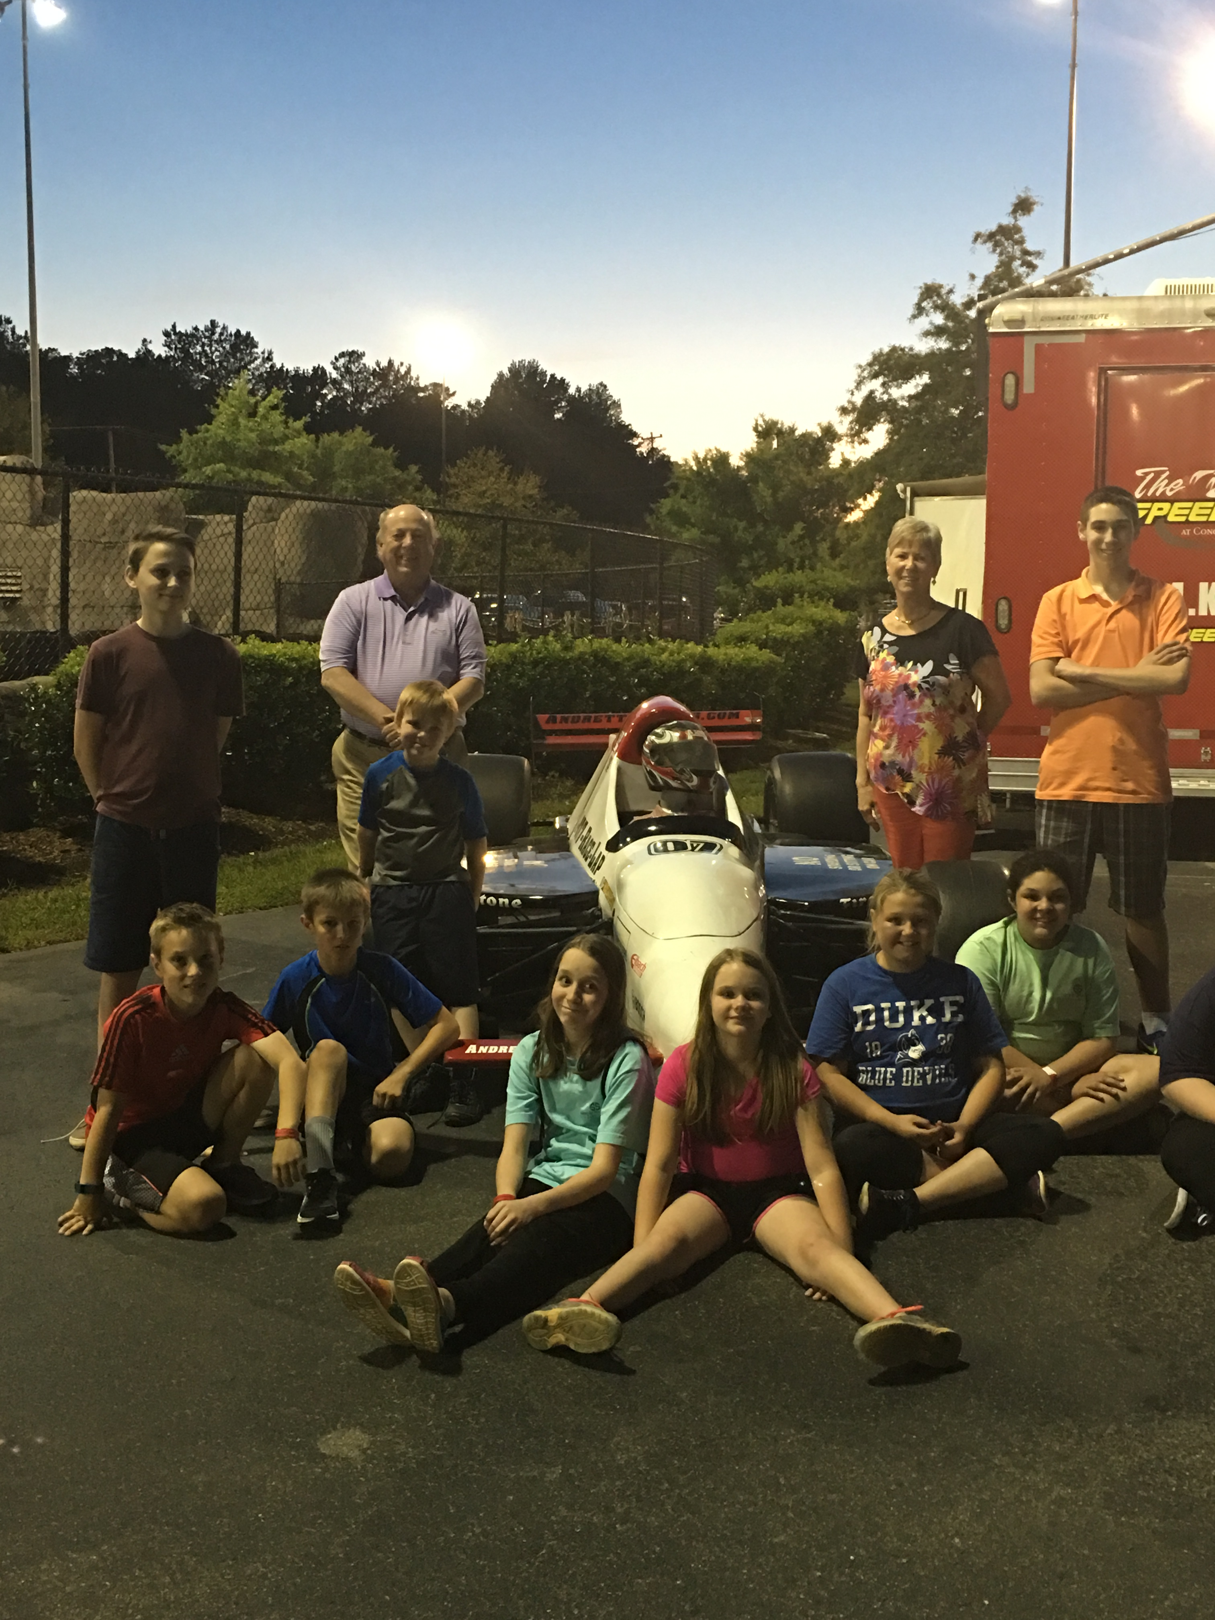

Youth Group Upcoming Events
Sunday July 24th
Meeting to organize items for Barium Springs.
Saturday July 30th
6pm Hickory Crawdads Game
(Christian concert following game)
Sunday August 4th
Deliver Barium Springs Supplies

Western North Carolina Presbytery News:

Teams meet with families impacted by record flooding

by Rick Jones | Presbyterian News Service
LOUISVILLE – The floodwaters are receding in West Virginia and families have begun the massive task of cleaning up following last week’s record flooding in parts of the state. As many as 23 people are known to have died in the flooding, while hundreds of homes and businesses have been damaged or completely destroyed.
After offering assistance, Rick Turner, associate for Disaster Response with Presbyterian Disaster Assistance, was contacted by state Presbyterian leaders on Friday.
One of hundreds of homes damaged or destroyed by record flooding in West Virginia. Photo by Phillip Darby.
“I began assembling a team to respond and then I heard the situation was far worse and was asked to send as many National Response Team members as I could,” he said. “I then changed from one team to two teams of three people. I also needed to have some NRT members standing by in case more are needed.”
The first team is headed by NRT member Liz Branch. She and other members spent Monday in White Sulphur Springs along the Greenbrier River, one of the hardest hit communities.
“There are cars submerged in the river and an entire sandbar of rock has been swept downstream. Houses are in various stages of mucking out. Most houses remain while at least one has been moved off of its foundation,” said Branch. “The National Guard is clearing out debris and various volunteer organizations are in town including FEMA and the Red Cross. They are in the early stages of trying to bring some normalcy back to the town.”
White Sulphur Springs drew national attention after video showed a burning home drifting downstream in the floodwaters. Branch describes the community now as very muddy adding that the threat of severe weather on Monday increased everyone’s anxiety levels again but the storms didn’t materialize.
“We’ve talked with a number of residents in the area. If they didn’t have a lot and lost everything, they’re toughing it out and going on saying they’re thankful to be alive,” said Branch. “The people who only saw a foot or two of water recognize that other people have had it worse. That’s their response.”
Branch said her team spent most of the day with emotional and spiritual care providers walking the neighborhoods and listening to people.
On Tuesday, the team moved on to Alderson, about 15 miles from White Sulphur Springs, another community along the Greenbrier River.
“We will continue to walk along the streets and talk with those sitting on their porches, and point them to services that are available,” said Branch. “Emergency teams are providing tetanus shots, distributing clothes and serving food to those who need them. We’re trying to be a communication link for people who are home and trying to clean up.”
The second team arrived on Monday. Both groups will continue to meet with residents and local church leaders over the coming days.
“I received a grant request for an initial response grant and have approved it,” said Turner. “It has been entered into the PC (USA) system for immediate response. These funds will make it possible for the presbytery to begin assisting with short-term recovery and with immediate needs within the impacted communities.”

Community News
SENIORS MORNING OUT PARTICIPANTS TO HAVE PICNIC, VISIT FARMERS MARKET
HICKORY – Participants in Catawba County’s Seniors Morning Out program will enjoy a picnic, visit the farmers market, and learn about a variety of subjects during the month of July.
Seniors Morning Out is a four-day-a-week program held in five different locations throughout the county. Any county resident who is 60 or better is invited to attend at no charge. In addition to entertaining and informative activities, the program provides a hot, balanced lunch. Activities vary by location. If you plan to attend, please notify the site supervisor at least 48 hours in advance to reserve your place. Transportation to and from the sites may be available.
All SMO sites will be closed July 4 in observance of Independence Day. All locations will travel to the farmers market on July 27 to shop for fresh fruits and vegetables. Some of the other program highlights, listed by location, are as follows.
West Hickory SMO, located at the West Hickory Senior Center, 400 17th St. SW, Hickory: July 5: Picnic with East Hickory SMO at Winkler’s Park with entertainment by Sentimental Journey; July 11: Laughing Yoga with Judy Stowe, Ice Cream Sundae Social and Sing-Along with Mabel Gabor; July12: Healthy Living with Meghan Lawton of the Alzheimer’s Association; July 14, Dancing to the Music of Sentimental Journey; July 19, Creating a Butterfly Haven; July 26, Cornerstones of Good Health with Carolyn Thompson, RN, of Catawba Valley Medical Center. To reserve your place, contact Lisa Adams at 828-323-8746.
East Hickory SMO, located at Huntington Hills Church of God, 2123 Fifth St. NE, Hickory: July 5, Picnic with West Hickory SMO at Winkler’s Park with Entertainment by Sentimental Journey; July 13: Game
Day with Horse Shoes, Ring Toss and Basketball; July 19, Sing Along with Slim Jim Phillips; July 20, Dancercise and Bingo; July 25, Block Walk and Bingo. To reserve your place, contact Rita Pritchard at 828-320-5963.
Newton SMO, located at First Presbyterian Church, 701 N. Main St. Newton: July 5: Birthday Party: Wear Red, White and Blue and Bring Snacks, the Rev. Daniel Brank to Sing; July 7, Shopping at Valley Hills Mall; July 12: Walk and Stretches and Family Feud; July 14, Homemade Ice Cream (Bring Toppings) and Frisbee Golf; July 19, Music by Sentimental Journey; July 20, Bingo with Agape Day Camp from St. Paul’s Lutheran; July 28: Forgetfulness: When Should You Be Concerned? By Tammy Jacobs and Rik Covalinski of Home Instead. To reserve your place, contact Robyn Curtis at 828-455-4133.
Catawba SMO, located at Center United Methodist Church, 4945 Sherrills Ford Road, Catawba: July 5: Bowling at Pin Station and Shopping at Honey’s IGA; July 13, Depression and Aging by Tammy Jacobs of Supportive Solutions; July 19, Music by the Clontz Family and Friends; July 21: Blood Pressure Checks and Exercises for Seniors by Jackie Saunders of Bayada Home Health; July 26: Music by Lonesome Road; July 28, Pizza Party (Cost $3) with Cornhole, Horse Shoes and Birdie Toss games. To reserve your place contact Wendy Thomas at 828-320-0434.
Maiden SMO, located at the Maiden Community Center, East Second Street and Klutz Street, Maiden: July 6: Bingo and Group Walking; July 11: Vegetable Bouquet with Thu Ngo and Group Exercise; July 14: Group Walking and Lunch at Newton Carillon; July 18: Living with Diabetes: Do You Know How to Eat Right? with Robin Tallent of Catawba Valley Medical Center: July 21: How to Pet a Porcupine: Don’t Get Stuck with Stress by Marsha Lynn, RN, of Hospice; July 25: Alzheimer’s Disease: What You Need to Know with Rik Covalinski of Home Instead and Tammi Jacobs of Supportive Solutions; July 26: Sentimental Journey Band and Group Singing. To reserve your place, contact Loretta Hefner at 828-3205966.
Senior Nutrition Services operates Seniors Morning Out, Meals on Wheels and related programs in the county. Volunteers are urgently needed to deliver Meals on Wheels. For more information, contact Senior Nutrition Services at 828-695-5610.

Ushers for the Month of July
Jane Shoemaker Bob Chambers
Dane Beatty Dennis Rumpf

Ushers for the Month of August

Ricky Beatty Bitsy Gregory
Richard Harwell Jenny Johnson

Acolytes
Alyssa Bandel
Mackenzie Pedicino

Happy Birthday
Birthdays are important because they indicate a special moment when God selected us to live in time. We are very special to have been chosen by Him to serve in His Kingdom in this generation. Please inform Carol Sticco if there are any additions or corrections needed.

July 2 Ikie Woodruff
July 4 Steve Mirman
July 6 Hilda Smith
July 10 Richard Harwell
July 11 Geneva Harwell
July 19 Caleb Bach
July 23 Linda Dillingham

August 3 Jerry Beatty
August 4 David Cross
August 5 Jane Shoemaker
August 14 Cindy Miller
August 20 Ramona Edwards
August 26 Jacob Phillips
August 28 Wendy Bandel

Happy Anniversary

July 5 Dane and Beatty Beatty

August 19 David and Heather Cross
August 22 Jerry and Joy Lynn Beatty
August 24 Steve and Kris Mirman
August 31 Jim and Ramona Edwards

Fellowship Hall
If you are interested in reserving the Fellowship Hall for your next special event, please visit the calendar on our website sfpchurch.org to check availability. You can also contact Carol Sticco at 828-217-5616.
The following dates are reserved:
- July 6 – Jackie Hefner
- July 17 – Cornelius Family Reunion
- August 27 – Gabriel Family Reunion
- September 11 – White Family Reunion
- September 18 – Beatty Family Reunion
- September 25 - Homecoming
- October 1st and 2nd – Willie Beatty’s Birthday Celebration
- October 8 – Community Day
- November 24 – Joan Washam Family

Recipe of the Month:
A simple combination - roasted corn with a basil vinaigrette - has a fresh flavor that is pure summer.
4 servings, about 1/2 cup each | Active Time: 15 minutes | Total Time: 40 minutes

Ingredients
- 3 cups fresh corn kernels
- 2 tablespoons extra-virgin olive oil
- 1/4 cup chopped fresh basil
- 1 tablespoon minced shallot
- 1 tablespoon red-wine vinegar
- 1/4 teaspoon salt
- Freshly ground pepper, to taste

Preparation
Preheat oven to 450°F. Toss corn and oil to coat and spread out on a large baking sheet. Bake, stirring once, until some kernels begin to brown, about 20 minutes. Combine basil, shallot, vinegar, salt and pepper in a medium bowl. Add the corn; toss to coat. Serve warm or cold.

Tips & Notes
Make Ahead Tip: Cover and refrigerate for up to 1 day.
Cut Down on Dishes: A rimmed baking sheet is great for everything from roasting to catching accidental drips and spills. For effortless cleanup and to keep your baking sheets in tip-top shape, line them with a layer of foil before each use.

