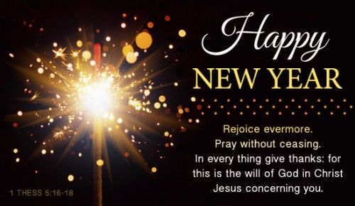
JANUARY/FEBRUARY 2016 NEWSLETTER
Sherrill’s Ford Presbyterian Mission Statement
We, the members of Sherrill’s Ford Presbyterian Church, are called by God
- To share the Gospel and bring others to Christ,
- To grow spiritually,
- To be a loving and supportive family in Christ,
- To work to make the world a better place to live.

Pastor’s Pulpit

SHERRILL’S FORD PRESBYTERIAN CHURCH
P. O. Box 246, Sherrill’s Ford, NC 28673
Phone: (828) 478-2223
Church Website: www.sfpchurch.org

Marcia and Russ Reighley, Pastors Elizabeth Brownell, Music Director
Carol Sticco, Clerk of Session Jane Shoemaker, Congregational Care Committee
Karen Phillips, Worship Sammy White, Building & Grounds
Lisa Hicks, Christian Education Dennis Rumpf, Fellowship
Roger Heffner, Mission

Elder of the Spotlight of the Month –
Karen Phillips - Worship
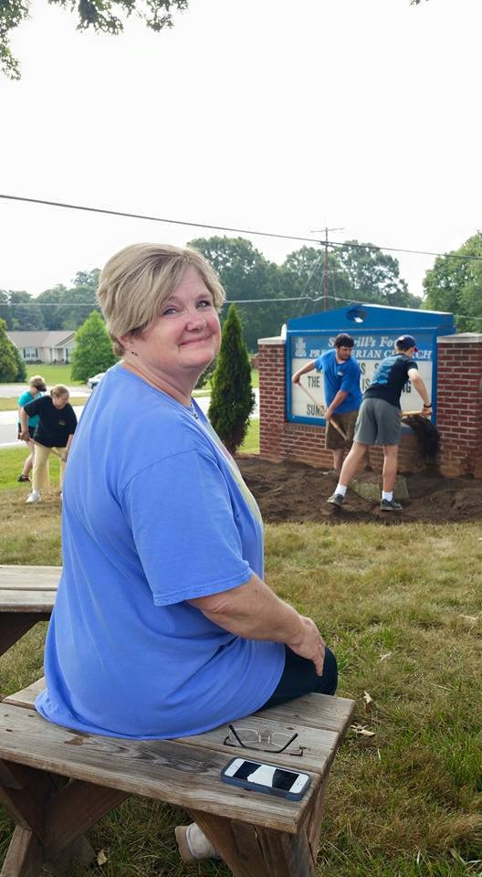

Weekly Events
Monday’s – 9:30am Crafts
Wednesday’s – 7:00pm AA Meeting
-7:00pm Acts Bible Study
Thursday’s – 7:00pm Choir Practice
Upcoming Events

Tuesday January 5th –
10 am – Presbyterian Woman’s Meeting

Monday January 11th –
3 pm Blood Drive

Sunday January 17th –
4 pm Cantata at Abernathy Laurels

Thursday January 21st –
9:00 am Son Shiners Breakfast

Tuesday February 2nd –
10 am Presbyterian Woman’s Meeting

Saturday February 6^{th -}
Oyster Stew Dinner

Sunday February 7th –
Communion Sunday

Thursday February 19th –
9 am Son Shiners Breakfast

We are so proud of all the great work our Western North Carolina Presbytery has accomplished:

Project is a ‘DREAAM’ come true for African-American boys at risk

LOUISVILLE—“Let’s rock the DREAAM House, Rock the DREAAM House.” Those are the words coming from 10 excited five-year-old boys participating in the DREAAM Summer Pre-K Academy. The DREAAM House is a new community-school partnership significantly funded by the First Presbyterian Church of Champaign and Southeastern Illinois Presbytery

Music Notes
The choir presented the Christmas cantata for the community and church during December. January 17th, we will be sharing our music with the residents at Abernathy Laurels in Newton. If you missed either performance in December, join us at 4:00 for the service. If you would like a real blessing, come at 3:15 and assist with transporting the residents to
the Spirit Room for the service. 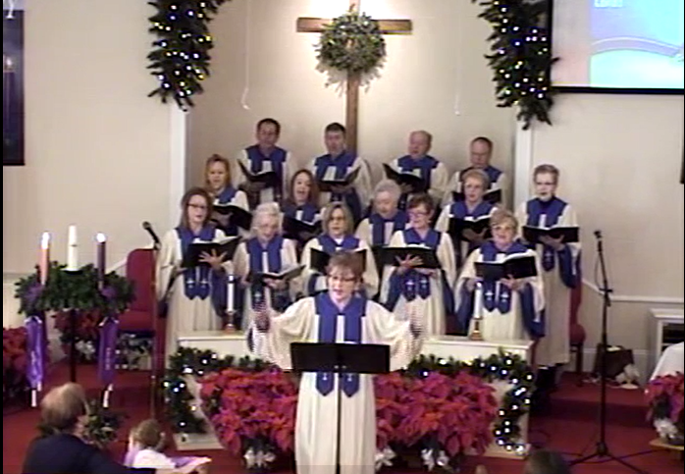

If you would like to join us and sing in the Easter cantata - without a commitment to sing on Sundays - we will begin rehearsing on Thursdays at 7:45. Please let me know as soon as possible so extra books and CDs can be ordered.

"Sing to Him, sing praises to Him; tell of all His wondrous works!" Psalm 105:2

Task Force Committee News
We are so thankful for all the task force has accomplished. The new audio/visual system is fully operational.
We are currently seeking volunteers that would be interested in operating the new audio/visual equipment. If interested please contact Carol Sticco (828) 217-5616. So that we can arrange a training date.

Community News
Message from the Catawba Council for seniors
We sincerely hope you had a joyous Christmas holiday!
Beat the winter doldrums and join us for some activities!
We have several programs that you might want to attend.
Qualified mental health counselors will be here to present a program on suicide and aging at the end of January.
The Arthritis Foundation sponsors a program about the benefits of Tai Chi for both the mind and body.
Come learn more about this!

Our tax counselors will return the first of February to help you with electronic filing.
You must have an appointment and our friendly volunteers will be happy to schedule one for you.
We have a new phone number to call beginning Tuesday, January 19th.
Be patient when calling…these nice ladies stay very busy!

Just want to relax and have some fun?
We host our annual Poor Man’s Lunch and Bingo in mid-January.
How about a Valentine’s Party in February with good gospel music?
Technology your thing? Loes Moore will be back to discuss Windows 10 and Tablets.
Our designer greeting cards teacher is adding a morning class each month.
Give us a call to get in on making these beautiful cards.
Get movin and grooving with our exercise, line dance, or yoga classes.
You’ll probably feel better in the long-run (it’s getting started that the hardest part!).
We’re working hard to get trips lined up for 2016.
Watch our March/April newsletter for opportunities to travel.
If you are interested in attending any of the programs listed above please call 828-328-2269 for more information.

Word of Thanks
We were so thankful and honored to have the Bells of Lake Norman join our Sherrill’s Ford Presbyterian Church choir in presenting an evening of music.

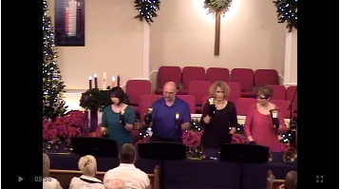

Past Events

Thank you Joy Lynn for making our Thanksgiving Table so beautiful.
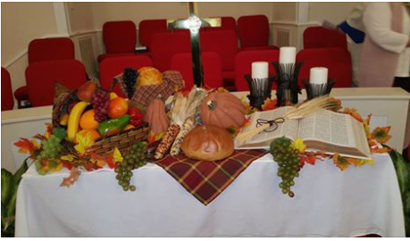

The Real Christmas Story

The Youth had such a wonderful time shopping for a very special family for Christmas.
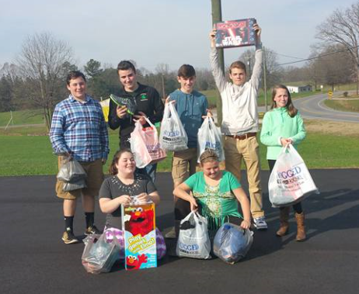

Our Youth Christmas Program, special thanks to Kresta Pedicino for making this such a huge success
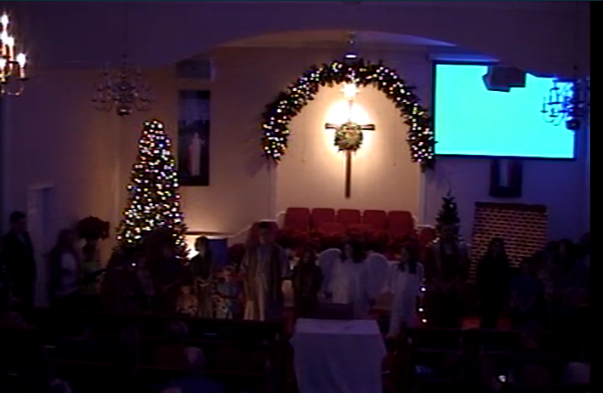

Teaching Scriptures for the month of January
1-3-2016; John 1: 10-18; Grace versus Law; Jesus is
the difference
1-10-2016; Luke 3: 15-17 & 21, 22: “Jesus’ baptism-
who received Grace?; plus Isaiah 43: 1; we are called by name
1-17-2016; John 2: 1-11; water into wine-where is
the Grace-for His mother, the bride, the guests, or the servants
1-24-2016; Luke 4: 14-21; proclaiming the scripture
(Isaiah 62: 1-5) to be fulfilled; there is a new beginning; Lynn Honeycutt will be the guest pastor; she may or may not use this scripture
1-31-2016; Luke 4: 21-31; rejected by His own; they
turned their backs on Grace; the option; Paul’s description of Love; 1Cor: 1-13
2-7-2016; Transfiguration; Luke 9: 28-43a; start
with Psalm 99; is this Grace for James, Peter, John, Elijah, Moses, or Jesus?
2-14-2016; (Lent starts); Luke 4: 1-13; Satan tempts
Jesus; I may use Psalm 91: 1-2; there is Grace in Faith and Persistence
2-21-2016; Luke 13: 31-35; Jesus leaves Jerusalem
but vows to come back; Psalm 27 (song “Whom Shall I Fear”) there is Grace in resolve
2-28-2016; Luke 13: 1-9; Jesus calls for repentance;
there is Grace in “Brutal Honesty” Psalm 63 (song “Oh God, You are My God”)

Ushers for the month of January
JW Brotherton Jackie Hefner
Dennis Rumpf Carol Sticco

Ushers for the month of February
Dane Beatty Richard Harwell
Roger Hefner Jane Shoemaker

Acolytes for the month of January
Mackenzie Pedicino

Acolytes for the month of February
Aaron Brownell

Happy Birthday
Birthdays are important because they indicate a special moment when God selected us to live in time. That further indicates that we are very special to have been chosen by Him to serve in His Kingdom in this generation! So let each of us share that special day by phoning, or writing a note to that special person in our congregation. (P.S. Please inform Carol Sticco if there are any additions or corrections needed)
January 1 Beth Caldwell
January 5 Aubrey Bach
January 5 James Houser
January 5 Robert Miller
January 6 Carl Hicks
January 7 Jim Edwards
January 12 JW Brotherton
January 13 Steve Caldwell
January 15 Jack Leonard
January 16 Roger Hefner
January 20 Andy Bandel
January 22 Kresta Pedicino
January 26 Susan Greenwood
January 27 Ryker Williams
January 29 Justin Pedicino
February 1 Chris Sticco
February 4 Joyce Alexander
February 14 Woody Alexander
February 18 Chad Williams
February 28 Jim Webb

Happy Anniversary
February 14 Harry and Dorothy Clifford

Fellowship Hall
If you are interested in reserving the Fellowship Hall for your next special event. Please visit our calendar on our website sfpchurch.org to check availability. You can also contact Carol Sticco at 828-217-5616.
The following dates are booked as of now:
- January 12 – Art Fair (Home School)
- January 23- Ryker’s Birthday Party
- February 6 – Oyster Stew Dinner
- February 19 – Father/Daughter Set Up for Dance (Home School)
- February 20 – Father/Daughter Dance (Home School)
- March 8 – International Day Fair (Home School)
- May 1 – PW Birthday Objective Program and Lunch
- May 13 – Awards Ceremony Set Up (Home School)
- May 14 – Awards Ceremony and Talent Show (Home School)
- July 17 – Gabriel Family Reunion

