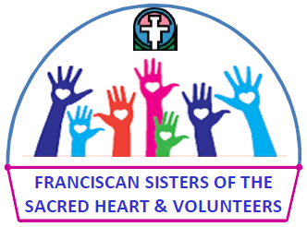

Volunteer APPLICATION

Name_________________________________________________________________________

Phone_______________________ Email____________________________________________

Birthday__________________

Address_______________________________________________________________________

City___________________________________________State__________ Zip______________

Employed by_________________________________________________________________________

Where_______________________________________________

Position____________________________Retired________________

Former Occupations ________________________________________________________________

Volunteer Experience____________________________________________________________

Skills, interests, hobbies_______________________________________________________________

Preference of volunteer jobs____________________________________________________________

Volunteer date and time preference ______________________________________________________

Reason for volunteering with the FSSH___________________________________________________

Have you been a volunteer with FSSH previously?________

If yes, what years and what did you do?_____________________________________________

Church affiliation (optional) ___________________________________

Do you have health insurance? _________________________________

Health concerns we should be aware of _________________________________________

References

Name _____________________________________ ___________ ______________________
Family
Address_______________________________________________________________________
Telephone _____________________

Name _________________________________________________ _____________________
Other
Address_______________________________________________________________________

Telephone _____________________

Name __________________________________________________ _____________________
Other
Address_______________________________________________________________________
Telephone ____________________
Emergency Contact and Relationship____________________________________________________
Telephone
Physician name and number _______________________________________________________
____________________________________________________ _____________
Applicant Signature Date

This information will be kept in the volunteer office, accessible to people who work in the volunteer office.
Please return application form to: Sister Margaret Anne Floto, OSF
Volunteer Coordinator
Franciscan Sisters of the Sacred Heart
9201 W. St. Francis Road
Frankfort, IL 60423-8330
smafloto@gmail.com

For Volunteer Department to complete

Orientation completed _____________________Release from Liability form signed _______________
Date Date

Photo release signed ________________ Code of Conduct signed _______________________
Date Date

Background check done __________ Protecting Gods Children program completed ___________
Date Date

January 2016

