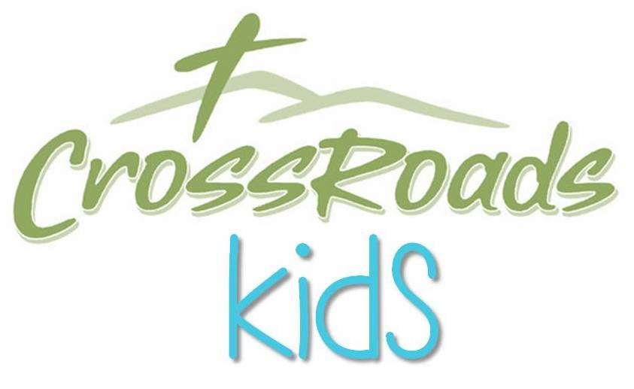

**2016-2017 Calendar**

**JULY 31 –** 12:30-2:00PM, Back to School Picnic & Open House– please bring a dish to share, 1:30PM, Young Disciples (5th-6th Grade) Info Meeting in KIDS Church,

2:00PM, 2016-2017 CM Volunteer Training

**AUGUST 1-4** – 10:00-4:00PM, Back to School Classroom Work Days, volunteers needed

**AUGUST 3 –** 6:00-9:00PM – Rising 7th Grade Picnic @ Daniel & Becky Rowe’s House

**AUGUST 7** – Promotion Sunday

**AUGUST 14** – 12:30-2:00PM, Young Disciples (5th-6th Grade) Pizza & Training Event

**AUGUST 31** – 6:30-8:00PM, CrossPath Kickoff

**SEPTEMBER 16** – 6:00-10:00PM - 5th-6th Grade Fall Frenzy

**OCTOBER 29 –** 4:00-6:00PM - Candy Carnival

**OCTOBER 30 –** 5th Sunday Family Connection

**NOVEMBER 6 –** PreK Promotion Sunday / Daylight Savings Time

**NOVEMBER 18** – 7:00-9:00PM - Elementary Memory Work Party

**DECEMBER 4 –** King’s Kids/Cherub Choir Performance

**DECEMBER 7** – End of CrossPath

**DECEMBER 16** – 6:00-10:00PM - 5th-6th Grade Christmas Movie Marathon

**JANUARY 29** - 5th Sunday Family Connection

**FEBRUARY 5 –** PreK Promotion Sunday & Young Disciples Training Lunch (12:30-2:00PM)

**FEBRUARY 24** - 7:00-9:00PM - Elementary Memory Work Party

**MARCH 17** – 6:00PM-10:00PM - 5th-6th Grade March Madness

**APRIL 8** – 11:00AM - Easter EGGstravaganza

**APRIL 16** - Easter

**APRIL 30** - 5th Sunday Family Connection - Parent & Child Dedication

**MAY 5** - 7:00-9:00PM - Elementary Memory Work Party

**May 7** – PreK Promotion Sunday

**JUNE 7–** 7:30-10:000PM – Crossroads Outdoor Movie Night

**JUNE 14, 21, 28, JULY 5 &12** – 6:30-8:00PM, VBS (age 3 – 6th Grade)

**JULY 19 –** 7:30-10:000PM – Crossroads Outdoor Movie Night