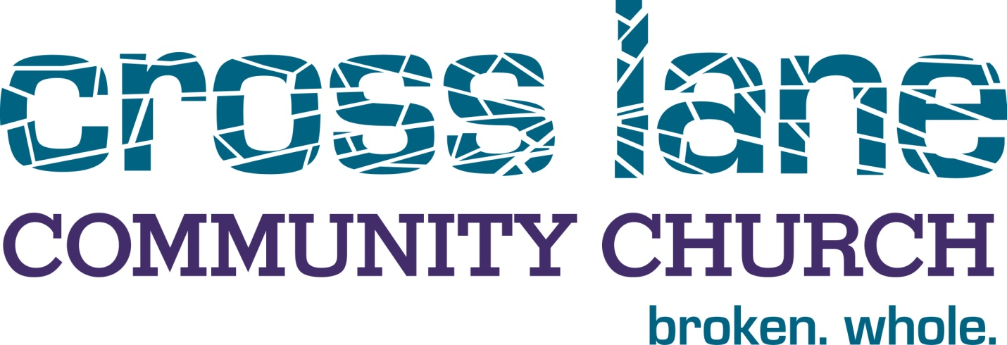

Foyer To Kitchen: The Foyer
The FOYER of your home is a very important place. It is the place you receive visitors and guests. Your foyer gives an impression, usually the first impression, to your guest about what kind of experience they can expect to have in your home. The word that is best associated with Cross Lane's FOYER environment, is the word GUEST. We meet guests in several different ways at Cross Lane. Two of the more prominent foyer environments are our web site, and our weekend services. (Our weekend service times are 9:00 a.m. and 10:30 a.m. on Sunday morning.) It is important to us that our guests want to come back to visit again, so we do our best to provide a positive experience when we get the opportunity to meet new friends. If you are new to our web site, we welcome you to come on in and look around. Here, you can get to know us at your leisure. You can learn about our vision and mission, you can listen to a sermon, check out what we believe and look into our youth ministry. If you decide you would like to visit us on a Sunday, (and we hope you will) you will find a very guest friendly environment. No one will put a name tag on you, and no one will make you stand up or draw any unwanted attention to you. You can expect a warm welcome, great worship music and a message that will be relevant and biblical. In short, our services are designed with the visitor in mind. We invite you to join us soon as we worship God together.

Foyer To Kitchen: The Living Room
Once a person is in your foyer, the next step is the LIVING ROOM. With the living room, we associate the word, FRIEND. When you sit down with someone in your living room, you do so in comfortable surroundings and the journey to friendship begins or continues. At Cross Lane, the Living Room consists of events where social interaction can take place. The Living Room environment is a place where you can meet people like yourself, where you can connect and make new friends. Concerts, celebrations, social gatherings and parties are all places where our guests become our friends. You can find out about these events in our bulletin on Sunday mornings, and on our web site.

Foyer to Kitchen: The Kitchen
If your home is typical, the KITCHEN is one of the most popular rooms in your home. Your family and your closest friends probably spend the most time in the kitchen. The kitchen is comfortable and safe. At Cross Lane the word we associate with the KITCHEN is FAMILY. Our Kitchen environment is made up of small groups, and we are striving to get as many people there as possible, because we want our guests to become our friends, and our friends to become our family. People involved in small groups at Cross Lane have committed to meet regularly for prayer, study, accountability and fellowship. They come together to ask and answer tough questions. There is community in our small groups, and we invite you to become a part of our Kitchen environment.

