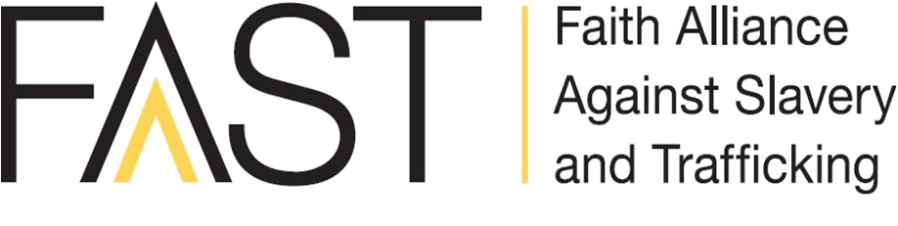
www.faastinternational.org
What is FAAST?

FAAST is a strategic alliance of Christian organizations working together to combat slavery and human trafficking.
Mission: Mobilize and equip communities to combat slavery and human trafficking and restore survivors.
Vision: We see a world of transformed communities, free of slavery and exploitation.

How does FAAST equip the church to combat human trafficking?

Resources available at faastinternational.org:
Hands that Heal Curriculum: This international curriculum for caregivers of sex trafficking survivors was written by over 40 academics and covers topics such as: what is Trafficking In Persons (TIP), the biblical response to TIP, the community response, and the physical, psychological, social and spiritual needs of survivors. Available for purchase.
Change Agents Curriculum: This 7 lesson bible-based pre-teen curriculum is aimed at educating children and families about human trafficking. Change Agents was created with the knowledge that children under the age of 14 could be uniquely vulnerable to trafficking. Use this curriculum as a tool to encourage children to become Change Agents who engage in anti-trafficking efforts. Available for purchase.
Prevention Bible Study: This 5 lesson Bible-based study is perfect for your small group or Bible Study. The lessons are aimed at adults who want to learn about human trafficking. This study will give you tools to stop trafficking before it starts in your own home/community. It focuses on prevention and how you can stop trafficking before it starts. This is an excellent resource for parents.
Awareness Bible Study: This 9 lesson study for adults looks at different forms of human trafficking, God’s heart for the exploited, and what the Christian’s response should be. The bible study includes a leader guide, a prayer guide, and an accompanying PowerPoint. Use this bible study in your church small group or with a group of friends. This Bible study is written with an international perspective.
Prayer Guide: This guide will walk you step-by-step through how to organize a prayer event for your church, including suggested scriptures to read and topics to pray about.
Engage Together Church Engagement Kit: Engage Together offers a valuable resource that explains how your church can engage in prevention, identification, rescue, and restoration of those affected by human trafficking.
Adopt-a-Mall Kit: Did you know malls are prime recruiting areas for human trafficking? This resource will empower you to take back your local mall by talking to security guards and retail workers about how to spot trafficking recruiters and victims. This includes an educational PowerPoint, a how-to guide and a speaking script to talk to others.
Chocolate Party Guide: This guide will teach you how to lead a discussion about labor trafficking and how it can be involved in the production of chocolate bars and other products. Learn about the power you have when making purchasing decisions. Use it with your small group or host a party for your entire congregation!
Movie Viewing Guide: This guide provides you with links to videos free videos about labor and sex trafficking as well as suggestions of other movies to watch. Grab some popcorn, your small group, or the entire congregation and sit down for an eye-opening move night. Discussion questions are also included.

Additional free resources:
U.S. Department of Health & Human Services: They provide fact sheets, campaign toolkits, educational brochures and posters, and pocket assessment cards on their website. (http://www.acf.hhs.gov/programs/endtrafficking/resources).
Department of Homeland Security: The DHS started the Blue Campaign to end human trafficking. On their website, you have the opportunity to order free posters and pamphlets that you could distribute in your church. (http://www.dhs.gov/blue-campaign/resource-catalog)
Polaris Project: Being the organization that runs the National Human Trafficking Resource Center hotline, Polaris Project has many resources on their website about how to take action against human trafficking, including how to call on Congress to address the issue. Try devoting a time during your small group to reach out to Congress! (www.polarisproject.org)

You can find even more resources on faastinternational.org!

