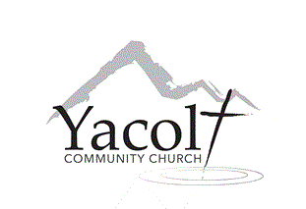

Please fill out the permission slip below

I hereby give my permission for all children listed below to participate in

___________________________________________________offsite activity with Yacolt Community Church. I understand that my children will be under adult supervision. I further understand that in signing this release form, I release and hold harmless the Yacolt Community Church, and any of its associated ministries. By signing this release form, I release and hold harmless its trustees, officers, employees, interns, and any volunteers from any liability, past or future, fully and completely. I authorize the staff or designated medical professionals to administer emergency medical assistance and/or transportation if I cannot be reached.

Date: _______________
Child Participant(s): _____________________________________________________
Parent or Legal Guardian signature: _________________________________________
Address: ______________________________________________________________
Phone: _________________________ Emergency Phone: ______________________
Emergency medical information (if any): _____________________________________
______________________________________________________________________
____________________________________________________________________________________________________________________________________________

