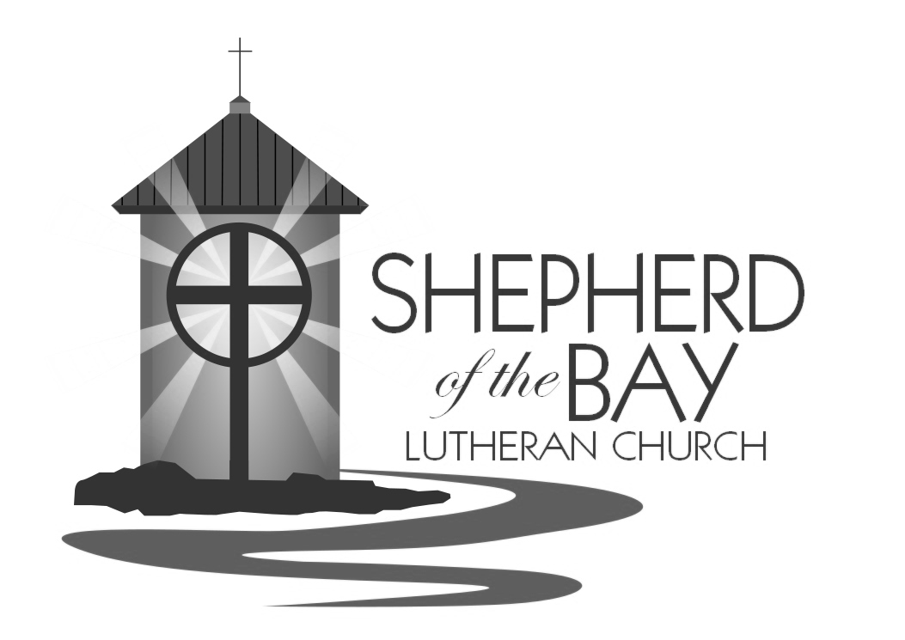

the proof of peace is yours
in the risen christ
easter 2
april 23, 2017

Shepherd of the BAy lutheran church | Lusby, Maryland
Growing Together in Faith

WELCOME TO WORSHIP
Welcome! Thank you for joining us this morning for worship. In our service we gather before our almighty God to offer him our worship and praise. We also gather to strengthen ourselves through the study of God’s holy and powerful word. We pray that your time with us this morning is edifying and enjoyable. May God bless our worship together this day!

for your assistance
- Restrooms are located down the hallway opposite the entrance to classroom 1, on the right.
- Ushers are here to help. Please don’t hesitate to ask them if you have any questions.
- A Cry-Room is available for mothers with infants in the church office. A live audio feed of the service is available in the room.
- Guest Register- We ask that our guests sign the worship register so that we might have record of who joined us and invite you to upcoming events. In order to do that we would invite you to leave your contact information on the spaces provided (i.e. email address, telephone number, or address) Thank you!
- Pastor Olson is available and willing to meet with you any time. Please give him a call at church 410-231-2075 or on his cell phone at 269-993-5766. He can also be reached via email pastor@shepherdofthebay.com. He would be happy to answer any questions or concerns you might have. Or you can stop by the office anytime for a cup of coffee and a chat.

PRAYER FOR BEFORE COMMUNION:
Lord, I am not worthy to be a guest at your holy table. But you are the friend of sinners, and you will not cast me out. This bread is your body, which bore my sins upon the tree. This wine is your blood, which purifies me from all guilt. At your invitation, I come rejoicing. Receive me, my Savior.

CLose Communion- Visitors, Please SPEAK WITH PASTOR BEFORE COMMUNING.
Through the Apostle Paul Jesus gives us specific instructions about this special Supper. He says, “Therefore, whoever eats the bread or drinks the cup of the Lord in an unworthy manner will be guilty of sinning against the body and blood of the Lord. A man ought to examine himself before he eats of the bread and drinks of the cup. For anyone who eats and drinks without recognizing the body of the Lord eats and drinks judgment on himself” (1 Corinthians 11:27-29). So that this Supper remains a blessing and not a harmful thing to those who partake of it – we feel a loving, God-given responsibility to instruct and train all who wish to receive this Supper prior to their participation. If you haven’t had the chance to receive instruction offered in this congregation or one of our sister congregations, we ask that you speak with the Pastor Olson before taking the Lord’s Supper. Pastor Olson is eager to meet with you. We thank you kindly. And we greatly look forward to celebrating the Lord’s Supper with you.
PRAYER FOR AFTER COMMUNION:
Thank you, Lord Jesus Christ, for nourishing me in this sacrament with your body and blood. You have given me forgiveness, life, and salvation. Let me always remain in you as a branch remains in the vine. Send me out in the power of your Spirit to live and work to your praise and glory.

Serving In Worship
Duty Councilman Steve Kopitzke
Music Terry Johnson
Ushers Steve Kopitzke and Tyler Holcomb
Video Duane Hintz
Greeter Zachariah Krauss
Altar Guild Linda Hardesty
Counters Heather Cornell & Mitchell Krauss
Refreshments Cornell Family
Flowers Cornell Family in honor of Aiden’s 2nd Birthday
Grass Cutting Team (April) Haack and Engelhaupt
Divine Service II

Opening hymn This Joyful Eastertide| CW 160

Confession of Sins and absolution
P: In the name of the Father and of the Son and of the Holy Spirit.
C: Amen.
P: Dear friends, let us approach God with a true heart and confess our sins, asking him in the name of our Lord Jesus Christ to forgive us.
C: Lord of life, I confess that I am by nature dead in sin.
For faithless worrying and selfish pride,
For sins of habit and sins of choice,
For the evil I have done and the good I have failed to do,
You should cast me away from your presence forever.
O Lord, I am sorry for my sins. Forgive me, for Jesus’ sake.

P: Christ has died. Christ is risen. Christ will come again. In his great mercy, God made us alive in Christ even when we were dead in our sins. Hear the word of Christ through his called servant: I forgive you all your sins in the name of the Father and of the Son and of the Holy Spirit.
C: Amen.

LORD, HAVE MERCY Kyrie
P: In peace, let us pray to the Lord.
For the well-being of all people everywhere, that they may receive from you all they need to sustain body and life, hear our prayer, O Lord.
C: Lord, have mercy.
P: For the spread of your life-giving gospel throughout the world, that all who are lost in sin may be brought to faith in you, hear our prayer, O Christ.
C: Christ, have mercy.
P: For patience and perseverance in this life, that we may not lose the hope of heaven as we await your return, hear our prayer, O Lord.
C: Lord, have mercy.
P: Lord of life, live in us that we may live for you.
C: Amen.

GLORY BE TO GOD Gloria in Excelsis
Sung to the tune of CW 152
1 All glory be to God on high!
Your name, O Lord, we glorify;
We praise you for your peace and grace,
Your favor toward our fallen race.
2 Our grateful thanks to you we bring,
For your great glory, heav’nly King,
For all, O Father, you have done
Through Jesus Christ, your only Son.

PRAYER OF THE DAY
P: The Lord be with you.
C: And also with you.
P: Let us pray.
O risen Lord, you came to your disciples and took away their fears with your word of peace. Come to us also by Word and sacrament, and banish our fears with the comforting assurance of your abiding presence; for you live and reign with the Father and the Holy Spirit, one God, now and forever.
C: Amen.

The Word

First Reading Acts 2:14, 22-32
Then Peter stood up with the Eleven, raised his voice and addressed the crowd:
²² “Men of Israel, listen to this: Jesus of Nazareth was a man accredited by God to you by miracles, wonders and signs, which God did among you through him, as you yourselves know. ²³ This man was handed over to you by God’s set purpose and foreknowledge; and you, with the help of wicked men, put him to death by nailing him to the cross. ²⁴ But God raised him from the dead, freeing him from the agony of death, because it was impossible for death to keep its hold on him. ²⁵ David said about him:
“ ‘I saw the Lord always before me.
Because he is at my right hand,
I will not be shaken.
²⁶ Therefore my heart is glad and my tongue rejoices;
my body also will live in hope,
²⁷ because you will not abandon me to the grave,
nor will you let your Holy One see decay.
²⁸ You have made known to me the paths of life;
you will fill me with joy in your presence.’
²⁹ “Brothers, I can tell you confidently that the patriarch David died and was buried, and his tomb is here to this day. ³⁰ But he was a prophet and knew that God had promised him on oath that he would place one of his descendants on his throne. ³¹ Seeing what was ahead, he spoke of the resurrection of the Christ, that he was not abandoned to the grave, nor did his body see decay. ³² God has raised this Jesus to life, and we are all witnesses of the fact.

REsponsive Song of Praise CW 153 Verse 1
Alleluia! Jesus lives! He is now the living one;
From the gloomy house of death Forth the conqueror has gone,
Bright foreruner to the skies
Of his people, yet to rise.

second Reading 1 Peter 1:3-9
³ Praise be to the God and Father of our Lord Jesus Christ! In his great mercy he has given us new birth into a living hope through the resurrection of Jesus Christ from the dead, ⁴ and into an inheritance that can never perish, spoil or fade—kept in heaven for you, ⁵ who through faith are shielded by God’s power until the coming of the salvation that is ready to be revealed in the last time. ⁶ In this you greatly rejoice, though now for a little while you may have had to suffer grief in all kinds of trials. ⁷ These have come so that your faith—of greater worth than gold, which perishes even though refined by fire—may be proved genuine and may result in praise, glory and honor when Jesus Christ is revealed. ⁸ Though you have not seen him, you love him; and even though you do not see him now, you believe in him and are filled with an inexpressible and glorious joy, ⁹ for you are receiving the goal of your faith, the salvation of your souls.

REsponsive Song of Praise CW 153 Verse 4
Jesus lives! And thus, my soul, Life is yours eternally;
Joined to him, your living head, Where he is, you too shall be;
You with him at his right hand
Victor over death shall stand.

Verse of the day
P: Alleluia. Alleluia. Christ is risen! He is risen indeed! Alleluia. Blessed are those who have not seen and yet have believed. Alleluia.
PLEASE STAND
P: The Gospel according to John chapter 20.
C: Glory be to you, O Lord.

gospel Reading John 20:19-31
On the evening of that first day of the week, when the disciples were together, with the doors locked for fear of the Jews, Jesus came and stood among them and said, “Peace be with you!” ²⁰ After he said this, he showed them his hands and side. The disciples were overjoyed when they saw the Lord.
²¹ Again Jesus said, “Peace be with you! As the Father has sent me, I am sending you.” ²² And with that he breathed on them and said, “Receive the Holy Spirit. ²³ If you forgive anyone his sins, they are forgiven; if you do not forgive them, they are not forgiven.”
²⁴ Now Thomas (called Didymus), one of the Twelve, was not with the disciples when Jesus came. ²⁵ So the other disciples told him, “We have seen the Lord!”
But he said to them, “Unless I see the nail marks in his hands and put my finger where the nails were, and put my hand into his side, I will not believe it.”
²⁶ A week later his disciples were in the house again, and Thomas was with them. Though the doors were locked, Jesus came and stood among them and said, “Peace be with you!” ²⁷ Then he said to Thomas, “Put your finger here; see my hands. Reach out your hand and put it into my side. Stop doubting and believe.”
²⁸ Thomas said to him, “My Lord and my God!”
²⁹ Then Jesus told him, “Because you have seen me, you have believed; blessed are those who have not seen and yet have believed.”
³⁰ Jesus did many other miraculous signs in the presence of his disciples, which are not recorded in this book. ³¹ But these are written that you may believe that Jesus is the Christ, the Son of God, and that by believing you may have life in his name.

P: This is the Gospel of the Lord.
C: Praise be to you, O Christ.

children’s Sermon
HYMN OF THE DAY O Sons and Daughters of the King| CW 165:1, 4-8

Sermon 1 Peter 1:3-9

You Have A Living Hope

THE NICENE CREED
We believe in one God, the Father, the Almighty, maker of heaven and earth, of all that is, seen and unseen.
We believe in one Lord, Jesus Christ, the only Son of God, eternally begotten of the Father, God from God, Light from Light, true God from true God, begotten, not made, of one being with the Father. Through him all things were made. For us and for our salvation, he came down from heaven, was incarnate of the Holy Spirit and the virgin Mary, and became fully human. For our sake he was crucified under Pontius Pilate. He suffered death and was buried. On the third day he rose again in accordance with the Scriptures. He ascended into heaven and is seated at the right hand of the Father. He will come again in glory to judge the living and the dead, and his kingdom will have no end.
We believe in the Holy Spirit, the Lord, the giver of life, who proceeds from the Father and the Son, who in unity with the Father and the Son is worshiped and glorified, who has spoken through the prophets. We believe in one holy Christian and apostolic Church. We believe in one baptism for the forgiveness of sins. We look for the resurrection of the dead and the life of the world to come. Amen.
OFFERING
The members of Shepherd of the Bay Lutheran Church have joined together to do the Lord's work in this community and around the world. Visitors need not feel obligated to participate in this offering which supports our ministry.

THE prayer of the church
The Sacrament
P: The Lord be with you.
C: And also with you.
P: Lift up your hearts.
C: We lift them up to the Lord.
P: Let us give thanks to the Lord our God.
C: It is good and right so to do.
P: It is truly good and right that we should at all times and in all places give you thanks, O Lord, holy Father, almighty and everlasting God, through Jesus Christ, our Lord, who rose from the dead in glorious triumph to bring forgiveness to the world and everlasting life to all who believe. Therefore, with all the saints on earth and hosts of heaven, we praise your holy name and join their glorious song:

Holy, Holy, Holy Sanctus
Sung to the tune of CW 130

2 Hosanna in the highest!
How truly blest is he
Who in God’s name is coming
To set his people free!
He comes to bring salvation
And with his blood outpoured,
Deliver us from bondage—
Hosanna, mighty Lord!

1 O holy, holy, holy
Lord God of pow’r and might,
Your glory, earth and heaven
In countless ways recite.
Hosanna! Come and save us,
Lord God of hosts on high,
And in your grace and mercy
Receive our fervent cry.

PRAYER OF THANKSGIVING
P: Blessed are you, O Lord of heaven and earth. We praise and thank you for sending your Son, Jesus Christ, and we remember the great acts of love through which he has ransomed us from sin, death, and the devil’s power.
By his incarnation, he became one with us.
By his perfect life, he fulfilled your holy will.
By his innocent death, he overcame hell.
By his rising from the grave, he opened heaven.
Invited by your grace and instructed by your Word, we approach your table with repentant and joyful hearts. Strengthen us through Christ’s body and blood, and preserve us in the true faith until we feast with him and all his ransomed people in glory everlasting.
C: Amen.
LORD’S PRAYER
C: Our Father in heaven, hallowed be your name, your kingdom come, your will be done on earth as in heaven. Give us today our daily bread. Forgive us our sins, as we forgive those who sin against us. Lead us not into temptation, but deliver us from evil. For the kingdom, the power, and the glory are yours, now and forever. Amen.
WORDS OF INSTITUTION
P: Our Lord Jesus Christ, on the night he was betrayed, took bread; and when he had given thanks, he broke it and gave it to his disciples, saying, “Take and eat; this is my body, which is given for you. Do this in remembrance of me.”
Then he took the cup, gave thanks, and gave it to them, saying, “Drink from it, all of you; this is my blood of the new covenant, which is poured out for you for the forgiveness of sins. Do this, whenever you drink it, in remembrance of me.”
The peace of the Lord be with you always.
C: Amen.
LAMB OF GOD John 1:29 Agnus Dei

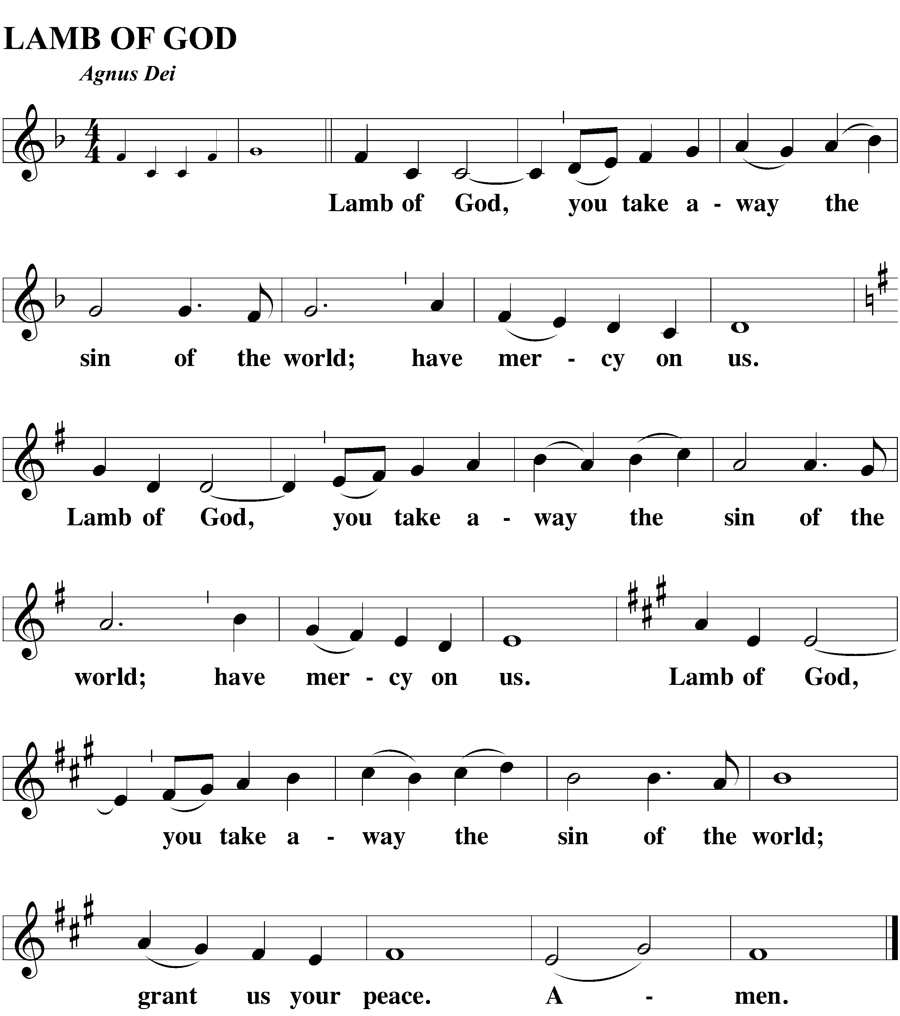
DISTRIBUTION
At Shepherd of the Bay, we practice the biblical teaching of close communion. See page 3 of the bulletin for more information. Visitors are asked to speak with Pastor before communing.

Distribution Music
SONG OF SIMEON Luke 2:29-32: Tune CW 130
Nunc Dimittis
2 All glory to the Father,
All glory to the Son,
All glory to the Spirit,
Forever three in one;
For as in the beginning,
Is now, shall ever be,
God’s triune name resounding
Through all eternity.

1 O Lord, now let your servant
Depart in peace, assured:
For I have seen your promised
incarnate, saving Word—
A Light that will enlighten
All gloom where Gentiles dwell;
The brilliant, crowning glory
Of those in Israel!

M: We give you thanks, O Lord, for the foretaste of the heavenly banquet that you have given us to eat and to drink in this sacrament. Through this gift, you have fed our faith, nourished our hope, and strengthened our love. By your Spirit help us to live as your holy people until that day when you will receive us as your guests at the wedding supper of the Lamb, who lives and reigns with you and the Holy Spirit, one God, now and forever.
C: Amen.
BLESSING Numbers 6:24-26
M: The Lord bless you and keep you.
The Lord make his face shine on you and be gracious to you.
The Lord look on you with favor and give you peace.
C: Amen.

closing hymn Jesus Lives! The Victory’s Won| CW 145

Week at a Glance
Today, Sunday, April 23rd
9:30 AM Bible Class/ Teen Class
10:30 AM Worship with Lord’s Supper
11:45 AM Quarterly Informational Meeting
Tuesday, April 25th
4:30 PM Bible Information Class
7:00 PM Bible Information Class
Thursday, April 27th
10:00 AM AA Meeting (Classroom 2)
12:00 PM Bible Information Class
Sunday, April 30th
9:30 AM Bible Study/ Teen Class
10:30 AM Worship

Thank you- A big thank you to each of you who helped plan, prepare, sing, play, feed, hide, hunt, guide and welcome for our Easter services last Sunday! A special thank you to Dan Hedegaard and Brian Hoerning for stripping and waxing our beuatiful floors!
Plan to stay for a brief Info Meeting this Sunday after worship. There's some really great things happening here at SotB ... find out what's new and what's upcoming!
LWMS Heritage Circuit Spring Rally will be held Saturday, April 29thin Roanoke, VA. Please see Edie Hintz or Elaine Hurley regarding a ride and rooms.
Mark your calendars for Spring Fest on Saturday, May 13th! This is a fun family event we offer free to the community. There will be carnival-type games, a bounce house, prizes, music, food, animals and rescue vehicles. It runs from 11am - 1pm in our parking lot. We're looking for plenty of volunteers to greet our guests, play games and serve food. Let Rachel F know you can help by emailing her at clubfedd@md.metrocast.net.

Our soccer camp is designed to improve the soccer skills of all the kids involved, whether they are beginners or already have some soccer experience. Our pastor loves the game of soccer and will be joined by college and high school players to build and improve the soccer skills of all. Our camp is about more than soccer. The theme is "Soccer is my game... Jesus is my life!" Pastor Olson will use the game of soccer to teach all the kids something so much more important than soccer- Jesus! Each day the children will hear a Bible lesson about Jesus' love. Besides improving your child's soccer skills with the help of a quality, caring coaching, your child will learn life lessons more important than soccer, meet friends, and make memories they'll cherish for a lifetime.

What: Shepherd of the Bay Soccer Camp
When: June 19-23, 2017 9am- 11:30am
Ages: 4-12 (All players- beginner or experienced- are welcome!)
Where: Southern Middle School (Field 3) 9615 HG Trueman Rd Lusby, MD 20657
Cost: $35 per child for the whole week! (Pay Online www.shepherdofthebay.com)
Receive: A knowledge of Jesus, their Savior, improvement of soccer skills, a snack every day, a water bottle, a soccer shirt, a soccer ball.
Registration: Advance online registration is required! (Registration deadline is June 4)

The name of the triune God and the sign of the cross remind worshippers of their baptisms.
The use of the keys is that special power and right which Christ gave to his church (believers) on earth: to forgive the sins of penitent sinners” See John 20:21-23.
Kyrie is the Greek word for Lord. The expression “Lord, have mercy” is one of the oldest worship responses in the Christian church.
Christians praise God by proclaiming the great things he has done to accomplish our rescue from sin. “Glory to God in the Highest” has been a Christian song of worship since the fourth century.
This greeting has deep roots in Christian worship and marks the beginning of the Word section and the Sacrament section of the service.
The congregation stands and speaks words of acclamation out of respect for the words of Christ, our King.
The Hymn of the Day is assigned to this day because of its rich content and connection to the day’s Gospel. Special music and accompaniments help this hymn to stand out.
Public confession is faith’s response to God’s saving Word. Christians composed the Nicene Creed in the fourth century to defend the Bible’s teachings that both Jesus Christ and the Holy Spirit are true God, equal to the Father in one eternal, undivided Trinity.
The original text here reads “catholic,” a word meaning “universal.” The Church consists of all believers in heaven and on earth, of every time in history.
Moved by God’s love in Christ, we offer him our first and best gifts, purely out of thanks to him.
The words of the Preface mark the beginning of the Sacrament section of the service and lift the worshipers’ hearts in praise. The opening sentences are among the oldest in the Christian liturgy.
Sanctus means “holy.” Used possibly as early as the second century, this canticle was in wide use among Christians in worship by the fourteenth century.
Jesus took bread and gave thanks [Matthew 26:26].
As he speaks the Words of Institution, the minister both proclaims the words of Jesus to the congregation and sets apart the bread and wine for the Lord’s use. The sign of the cross reminds us of Christ's death.
Jesus is God’s Lamb [Agnus Dei], who was offered as a sacrifice for sin once for all.
The Scriptures teach that the celebration of the Lord’s Supper connects us intimately with Christ and with one another as Christians who are united around a common confession of faith.
The Nunc Dimittis [“Now dismiss”] is also known as the “Song of Simeon.” Through God’s Word and Sacrament, we have seen Jesus Christ, and like Simeon we find divine peace and comfort through faith in the Savior.
The blessing of Aaron has been spoken over God’s people for over 3,500 years. The Lord said, “So they will put my name on [them], and I will bless them” [Numbers 6:27].

