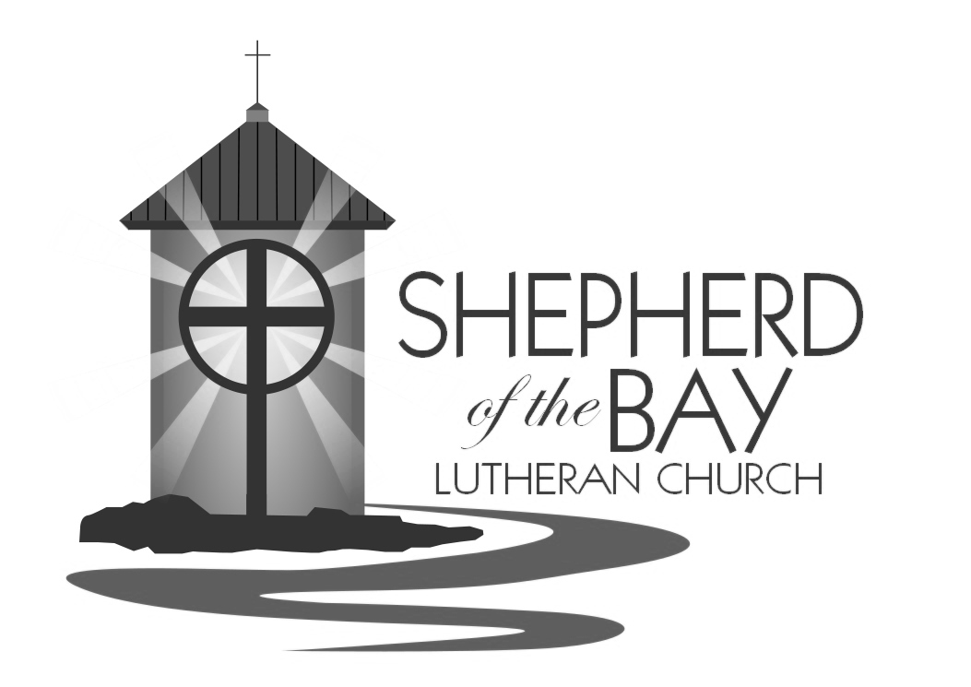

LOVE YOUR ENEMIES!
Epiphany 7
february 19, 2017

Shepherd of the BAy lutheran church | Lusby, Maryland
Growing Together in Faith

WELCOME TO WORSHIP
Welcome! Thank you for joining us this morning for worship. In our service, we gather before our almighty God to offer him our worship and praise. We also gather to strengthen ourselves through the study of God’s holy and powerful Word. We pray that your time with us this morning is edifying and enjoyable. May God bless our worship together this day!

for your assistance
- Restrooms are located down the hallway opposite the entrance to classroom 1, on the right.
- Ushers are here to help. Please don’t hesitate to ask them if you have any questions.
- A Cry-Room is available for mothers with infants in the church office. A live audio feed of the service is available in the room.
- Guest Register- We ask that our guests sign the worship register so that we might have record of who joined us and invite you to upcoming events. In order to do that we would invite you to leave your contact information on the spaces provided (i.e. email address, telephone number, or address) Thank you!
- Pastor Olson is available and willing to meet with you any time. Please give him a call at church 410-231-2075 or on his cell phone at 269-993-5766. He can also be reached via email pastor@shepherdofthebay.com. He would be happy to answer any questions or concerns you might have. Or you can stop by the office anytime for a cup of coffee and a chat.

CLose Communion- Visitors, Please SPEAK WITH PASTOR BEFORE COMMUNING.
Through the Apostle Paul Jesus gives us specific instructions about this special Supper. He says, “Therefore, whoever eats the bread or drinks the cup of the Lord in an unworthy manner will be guilty of sinning against the body and blood of the Lord. A man ought to examine himself before he eats of the bread and drinks of the cup. For anyone who eats and drinks without recognizing the body of the Lord eats and drinks judgment on himself” (1 Corinthians 11:27-29). So that this Supper remains a blessing and not a harmful thing to those who partake of it – we feel a loving, God-given responsibility to instruct and train all who wish to receive this Supper prior to their participation. If you haven’t had the chance to receive instruction offered in this congregation or one of our sister congregations, we ask that you speak with the Pastor Olson before taking the Lord’s Supper. Pastor Olson is eager to meet with you. We thank you kindly. And we greatly look forward to celebrating the Lord’s Supper with you.
PRAYER FOR BEFORE COMMUNION:
Lord, I am not worthy to be a guest at your holy table. But you are the friend of sinners, and you will not cast me out. This bread is your body, which bore my sins upon the tree. This wine is your blood, which purifies me from all guilt. At your invitation, I come rejoicing. Receive me, my Savior.
PRAYER FOR AFTER COMMUNION:
Thank you, Lord Jesus Christ, for nourishing me in this sacrament with your body and blood. You have given me forgiveness, life, and salvation. Let me always remain in you as a branch remains in the vine. Send me out in the power of your Spirit to live and work to your praise and glory.

Serving In Worship
Duty Councilman Bob Gillett
Music Sam Holcomb
Ushers Bob Gillett and Tyler Holcomb
Video Duane Hintz
Greeter Zachariah Krauss
Altar Guild Rachel Olson
Counters Chuck Fick & Melissa Christensen
Refreshments ..Bassett Family
Flowers Krauss Family

Divine SErvice 1

Opening HYMN Every Morning Mercies New | CW 580

M: In the name of the Father and of the Son and of the Holy Spirit.
C: (spoken) Amen.
CONFESSION OF SINS
M: Beloved in the Lord: let us draw near with a true heart and confess our sins to God our Father, asking him in the name of our Lord Jesus Christ to grant us forgiveness.
C: Holy and merciful Father, I confess that I am by nature sinful and that I have disobeyed you in my thoughts, words, and actions. I have done what is evil and failed to do what is good. For this I deserve your punishment both now and in eternity. But I am truly sorry for my sins, and trusting in my Savior Jesus Christ, I pray: Lord, have mercy on me, a sinner.
LORD, HAVE MERCY
Kyrie
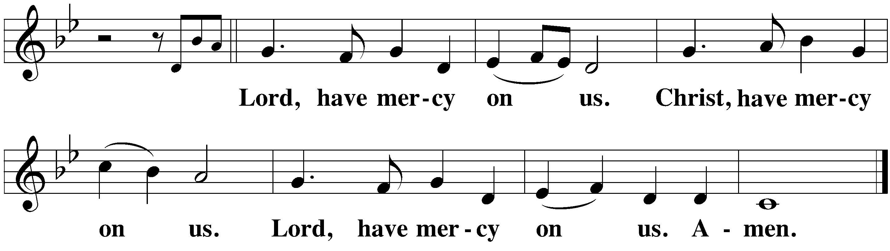
M: God, our heavenly Father, has been merciful to us and has given his only Son to be the atoning sacrifice for our sins. Therefore, as a called servant of Christ and by his authority, I forgive you all your sins in the name of the Father and of the Son (+) and of the Holy Spirit.
C: (spoken) Amen.

PRAYER AND PRAISE
M: In the peace of forgiveness, let us praise the Lord.
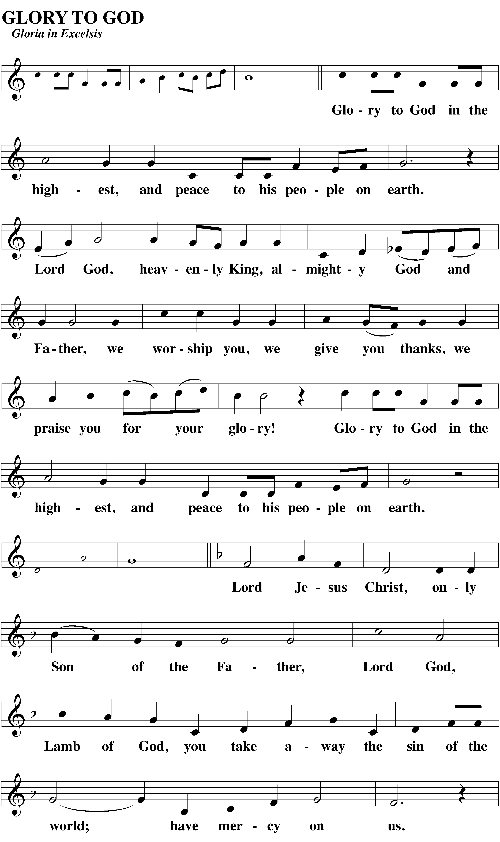
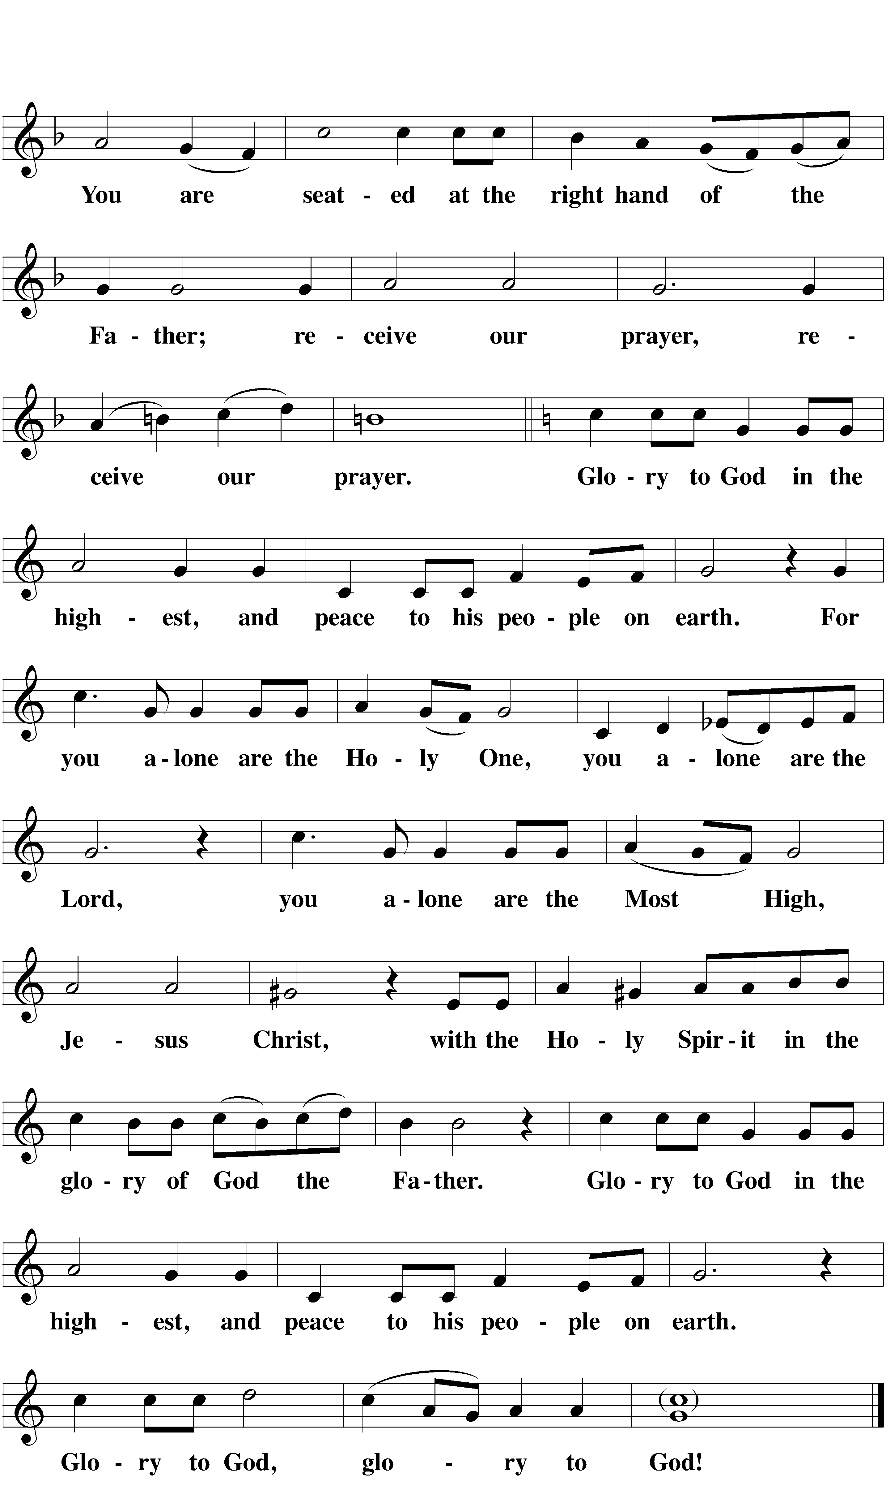
PRAYER OF THE DAY
M: The Lord be with you.
C: And also with you.

M: Let us pray.
Gracious Father, keep your family, the Church, always faithful to you, that we may lean on the hope of your promises and be strong in the power of your love; through your Son, Jesus Christ our Lord, who lives and reigns with you and the Holy Spirit, one God, now and forever.
C: (spoken) Amen.
The Word

First Reading Leviticus 19:1,2,17,18

The Lord said to Moses, ² “Speak to the entire assembly of Israel and say to them: ‘Be holy because I, the Lord your God, am holy. ¹⁷ “Do not hate your brother in your heart. Rebuke your neighbor frankly so you will not share in his guilt.
¹⁸ “Do not seek revenge or bear a grudge against one of your people, but love your neighbor as yourself. I am the Lord.

RESPONSIVE SONG CW 538:1-2

1 The Church’s one foundation Is Jesus Christ, her Lord;
She is his new creation By water and the Word.
From heav’n he came and sought her To be his holy bride;
With his own blood he bought her, And for her life he died.

2 Elect from ev’ry nation, Yet one o’er all the earth;
Her charter of salvation: One Lord, one faith, one birth.
One holy name she blesses, Partakes one holy food,
And to one hope she presses, With ev’ry grace endued.

second Reading Romans 12:9-21
⁹ Love must be sincere. Hate what is evil; cling to what is good. ¹⁰ Be devoted to one another in brotherly love. Honor one another above yourselves. ¹¹ Never be lacking in zeal, but keep your spiritual fervor, serving the Lord. ¹² Be joyful in hope, patient in affliction, faithful in prayer. ¹³ Share with God’s people who are in need. Practice hospitality.
¹⁴ Bless those who persecute you; bless and do not curse. ¹⁵ Rejoice with those who rejoice; mourn with those who mourn. ¹⁶ Live in harmony with one another. Do not be proud, but be willing to associate with people of low position. Do not be conceited.
¹⁷ Do not repay anyone evil for evil. Be careful to do what is right in the eyes of everybody. ¹⁸ If it is possible, as far as it depends on you, live at peace with everyone. ¹⁹ Do not take revenge, my friends, but leave room for God’s wrath, for it is written: “It is mine to avenge; I will repay,” says the Lord. ²⁰ On the contrary:
“If your enemy is hungry, feed him;
if he is thirsty, give him something to drink.
In doing this, you will heap burning coals on his head.”
²¹ Do not be overcome by evil, but overcome evil with good.

Verse of the day
P Alleluia. Be merciful, just as your Father is merciful. Alleluia.
Please Stand
After the announcement of the Gospel, the congregation sings:
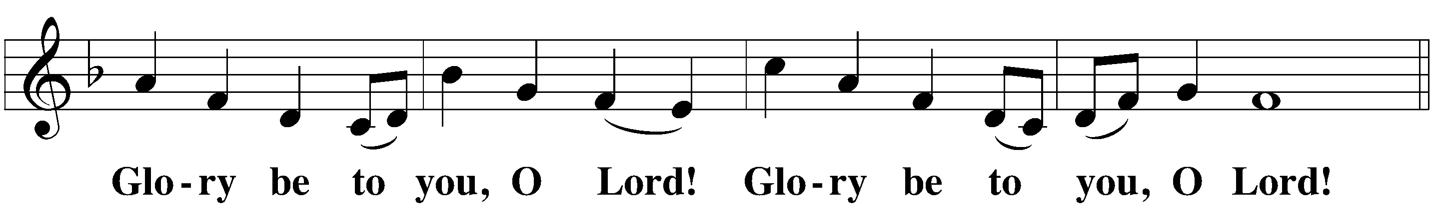

gospel Reading Matthew 5:38-48
³⁸ “You have heard that it was said, ‘Eye for eye, and tooth for tooth.’ ³⁹ But I tell you, Do not resist an evil person. If someone strikes you on the right cheek, turn to him the other also. ⁴⁰ And if someone wants to sue you and take your tunic, let him have your cloak as well. ⁴¹ If someone forces you to go one mile, go with him two miles. ⁴² Give to the one who asks you, and do not turn away from the one who wants to borrow from you.
⁴³ “You have heard that it was said, ‘Love your neighbor and hate your enemy.’ ⁴⁴ But I tell you: Love your enemies and pray for those who persecute you, ⁴⁵ that you may be sons of your Father in heaven. He causes his sun to rise on the evil and the good, and sends rain on the righteous and the unrighteous. ⁴⁶ If you love those who love you, what reward will you get? Are not even the tax collectors doing that? ⁴⁷ And if you greet only your brothers, what are you doing more than others? Do not even pagans do that? ⁴⁸ Be perfect, therefore, as your heavenly Father is perfect.
After the Gospel, the congregation sings:
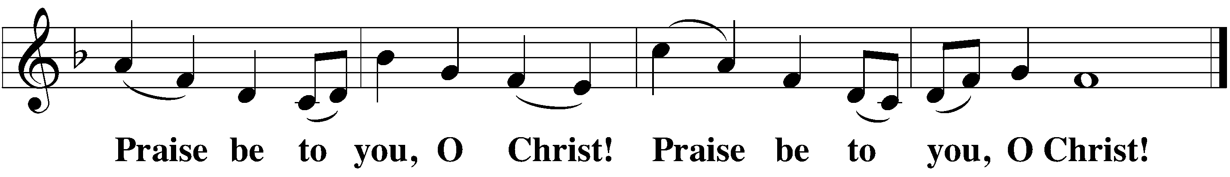
CHILDREN’S MESSAGE
THE NICENE CREED
We believe in one God, the Father, the Almighty,
maker of heaven and earth,
of all that is,
seen and unseen.
We believe in one Lord, Jesus Christ, the only Son of God,
eternally begotten of the Father,
God from God, Light from Light, true God from true God,
begotten, not made,
of one being with the Father.
Through him all things were made.
For us and for our salvation, he came down from heaven,
was incarnate of the Holy Spirit and the virgin Mary,
and became fully human.
For our sake he was crucified under Pontius Pilate.
He suffered death and was buried.
On the third day he rose again in accordance with the Scriptures.
He ascended into heaven
and is seated at the right hand of the Father.
He will come again in glory to judge the living and the dead,
and his kingdom will have no end.
We believe in the Holy Spirit,
the Lord, the giver of life,
who proceeds from the Father and the Son,
who in unity with the Father and the Son is worshiped and glorified, who has spoken through the prophets.
We believe in one holy Christian and apostolic Church.
We acknowledge one baptism for the forgiveness of sins.
We look for the resurrection of the dead
and the life of the world to come. Amen.

HYMN OF THE DAY Son of God, Eternal Savior | CW 492

Sermon After the sermon, the congregation stands and sings: 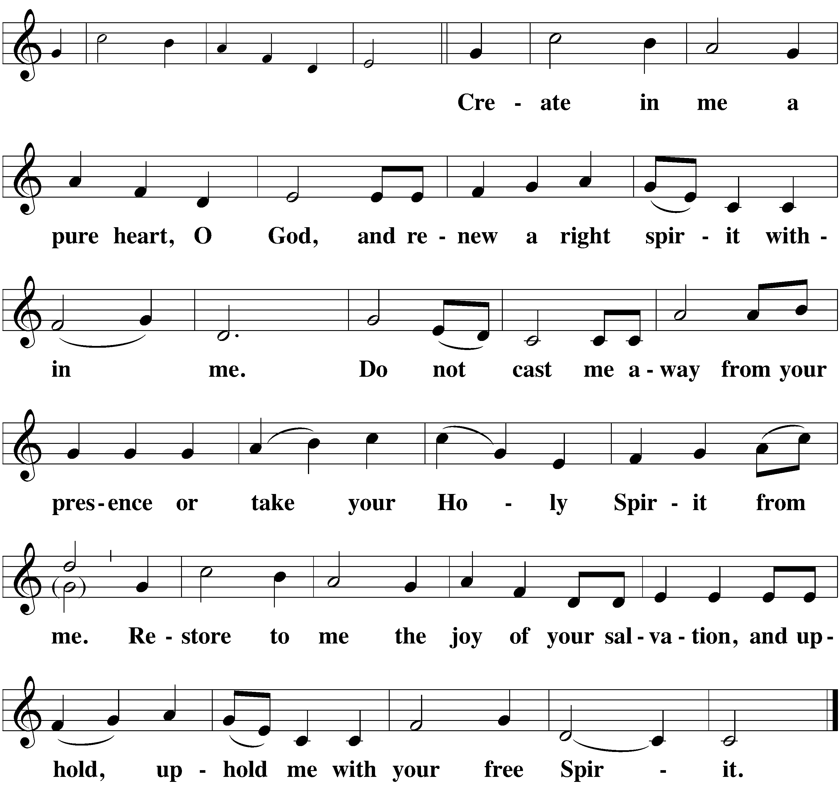

offering
The members of Shepherd of the Bay Lutheran Church have joined together to do the Lord's work in this community and around the world. Visitors need not feel obligated to participate in this offering which supports our ministry.

Prayer of the Church
LORD'S PRAYER
C: Our Father in heaven, hallowed be your name, your kingdom come, your will be done on earth as in heaven. Give us today our daily bread. Forgive us our sins, as we forgive those who sin against us. Lead us not into temptation, but deliver us from evil. For the kingdom, the power, and the glory are yours, now and forever. Amen.

THE SACRAMENT
M: The Lord be with you.
C: And also with you.
M: Lift up your hearts.
C: We lift them up to the Lord.
M: Let us give thanks to the Lord, our God.
C: It is good and right so to do.
M: It is truly good and right that we should at all times and in all places give you thanks, O Lord, holy Father, almighty and everlasting God, through Jesus Christ, our Lord, who lived among us as a human being and revealed his glory as your only Son, full of grace and truth. Therefore, with all the saints on earth and hosts of heaven, we praise your holy name and join their glorious song:

HOLY, HOLY, HOLY
Sanctus
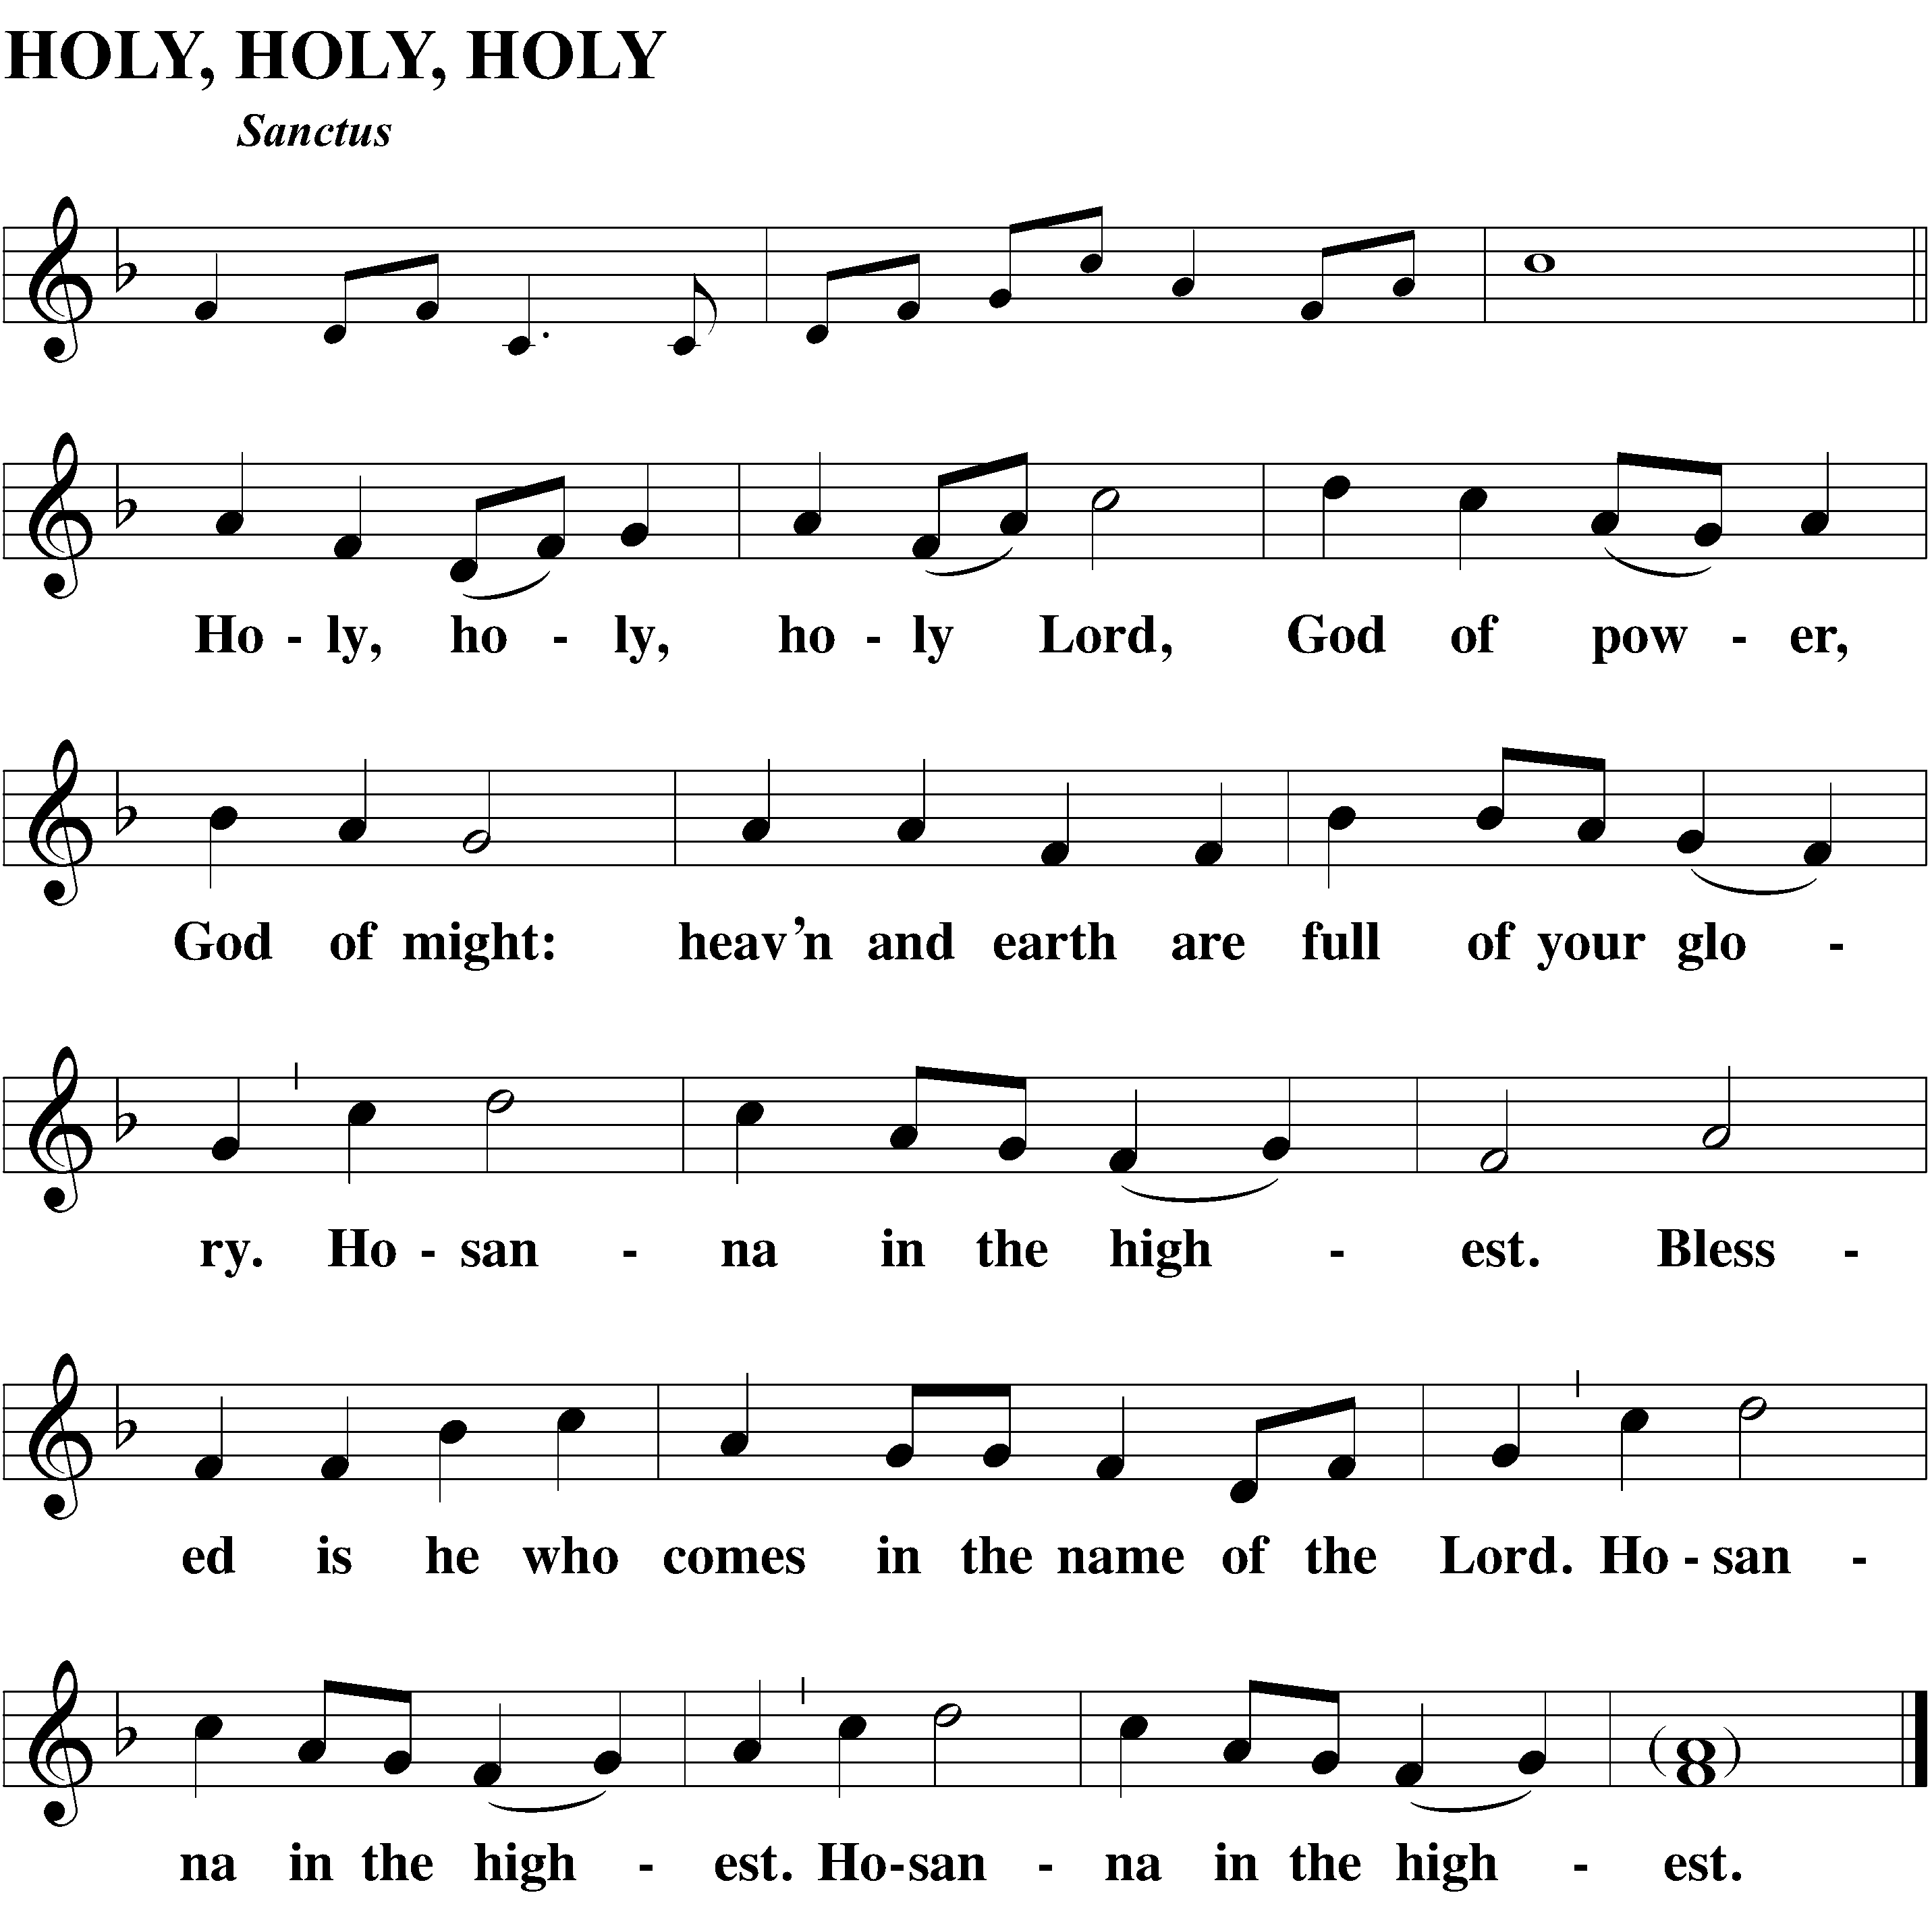
WORDS OF INSTITUTION
M: Our Lord Jesus Christ, on the night he was betrayed, took bread; and when he had given thanks, he broke it and gave it to his disciples, saying, “Take and eat; this is my (+) body, which is given for you. Do this in remembrance of me.”
Then he took the cup, gave thanks, and gave it to them, saying, “Drink from it, all of you; this is my (+) blood of the new covenant, which is poured out for you for the forgiveness of sins. Do this, whenever you drink it, in remembrance of me.”
The peace of the Lord be with you always.
C: (spoken) Amen.
O CHRIST, LAMB OF GOD
Agnus Dei

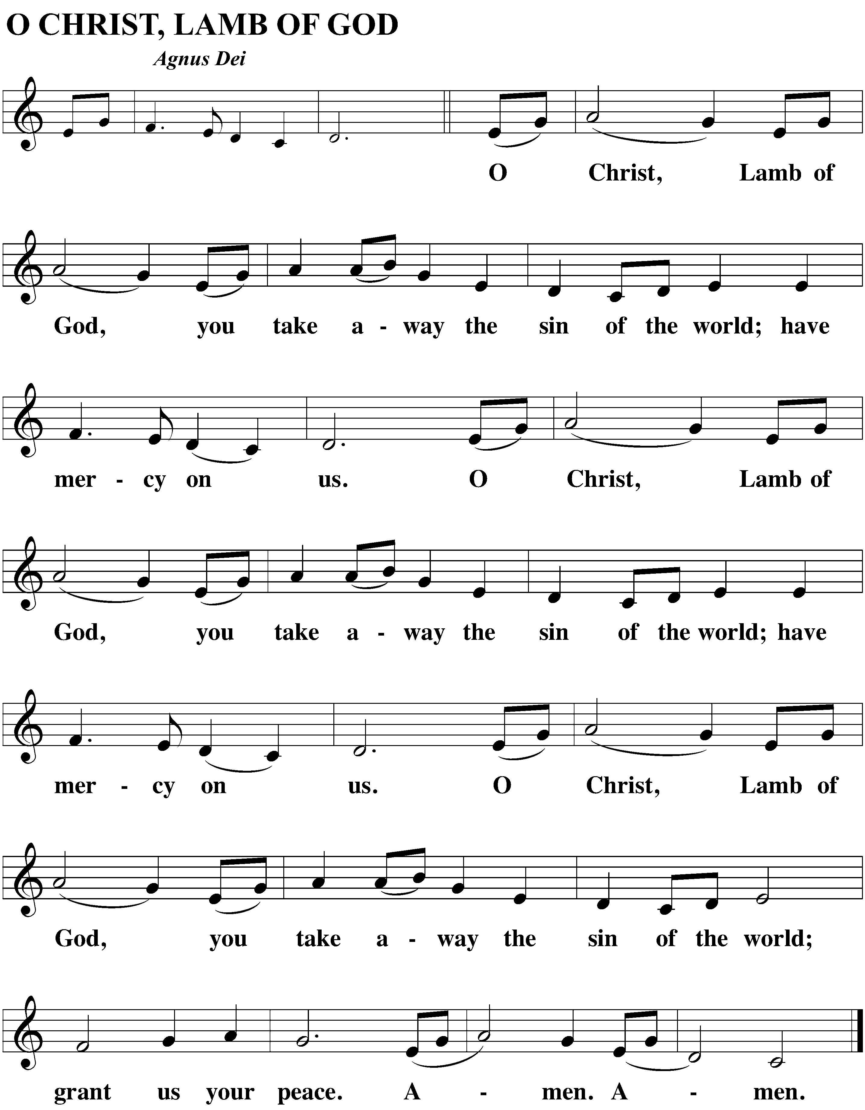

BE SEATED
DISTRIBUTION
At Shepherd of the Bay, we practice the biblical teaching of close communion. See page 3 of the bulletin for more information. Visitors are asked to speak with Pastor before communing

DISTRIBUTION MUSIC

SONG OF SIMEON
Nunc Dimittis
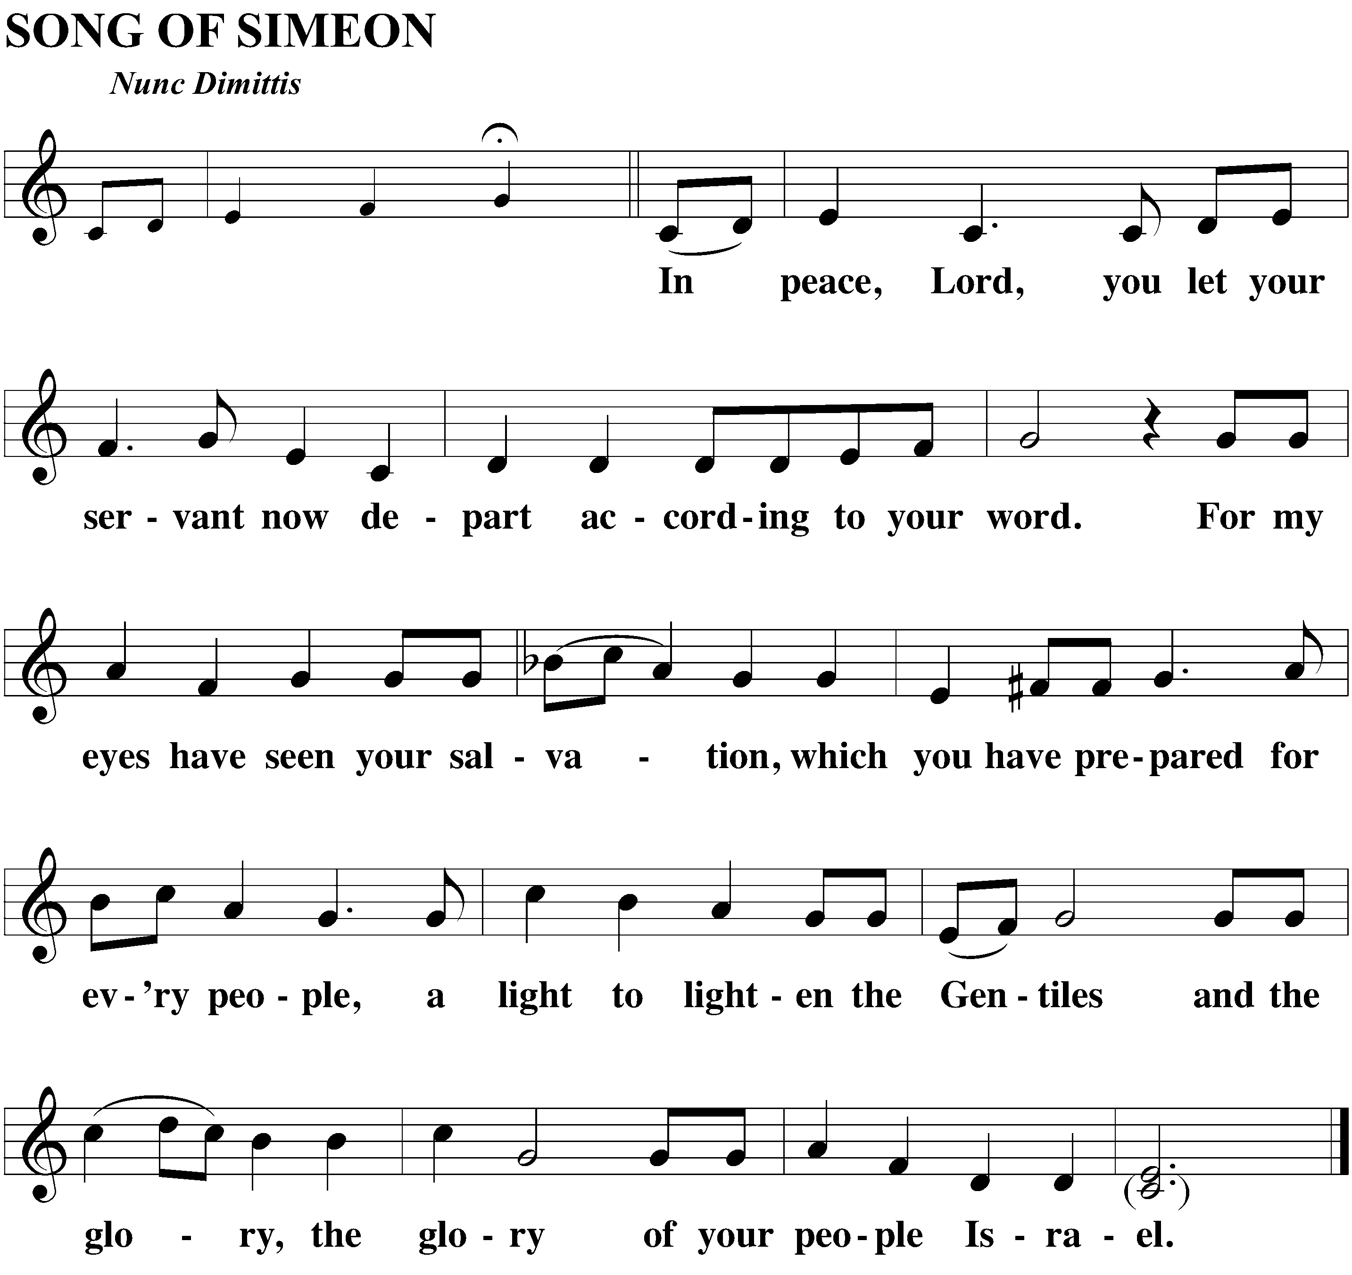

M: O give thanks to the Lord, for he is good.
C: And his mercy endures forever.

M: We give thanks, almighty God, that you have refreshed us with this Holy Supper. We pray that through it you will strengthen our faith in you and increase our love for one another. We ask this in the name of Jesus Christ, our Lord, who lives and reigns with you and the Holy Spirit, one God, now and forever.

C: (spoken) Amen.

M: The Lord bless you and keep you.
The Lord make his face shine on you and be gracious to you.
The Lord look on you with favor and (+) give you peace.
C: (spoken) Amen.

closing hymn The Church’s One Foundation | CW 538:3-5

Week at a Glance
Today, Sunday, February 19th
9:30 AM Bible Class/ Teen Class
10:30 AM Worship w/ Lord’s Supper
12:00 PM Choir
Tuesday, February 21st
7:00 PM Bible Information Class
Wednesday, February 22nd
9:00 AM Bible Information Class
7:00 PM Roman’s Bible Class
9:00 PM Mysterious Marriage Online Class
Thursday, February 23rd
10:00 AM AA Meeting (Classroom 2)
6:30 PM Catechism Class
Saturday, February 25th
8:30 AM Men’s Breakfast/ Augsburg Confession
Teen Ski Trip (Weather Pending)
Sunday, February 26th
9:30 AM Bible Study/ Teen Class
10:30 AM Worship
12:00 PM Choir

Thank you- Thank you to Steve Kopitzke for organizing the Pine Car Race! Thank you to the Cornell’s for hosting Taco/ Game night!
Mornings with Mommy is a fun and easy way for you to enjoy activities with your children and meet other moms. Each session has a fun theme that includes age appropriate activities for infants, toddlers and preschoolers. And the best part is, we do all the planning, you just sign up! Moms can mingle with each other and enjoy activities with their children including: arts and crafts, sensory table, flannel stories and story time, music, educational toys, and a snack. REGISTER ASAP! (Only 4 spots left:)

