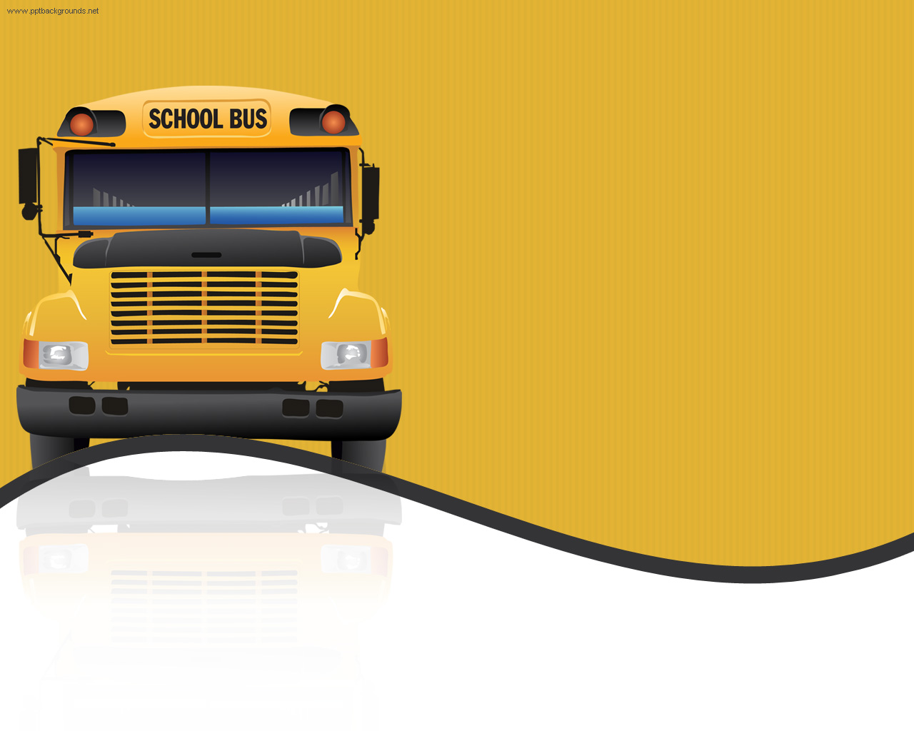 WWgewe When

When summer break comes to an end, many children in our community will need school supplies. The Mebane UMW is sponsoring a Back to School Supply drive and we invite ALL to participate and deliver your items at the ramp entrance through August.

Backpacks

Blunt round tip scissors

Composition Books

8 ½ x 11 ruled loose leaf paper

Rulers

Pencils with erasers

Erasers

Boxes of 24 crayons (only 24)

Hand held pencil sharpeners

**Back to School Supplies Ministry**

**Back to School Supplies Ministry**

**Back to School Supplies Ministry**